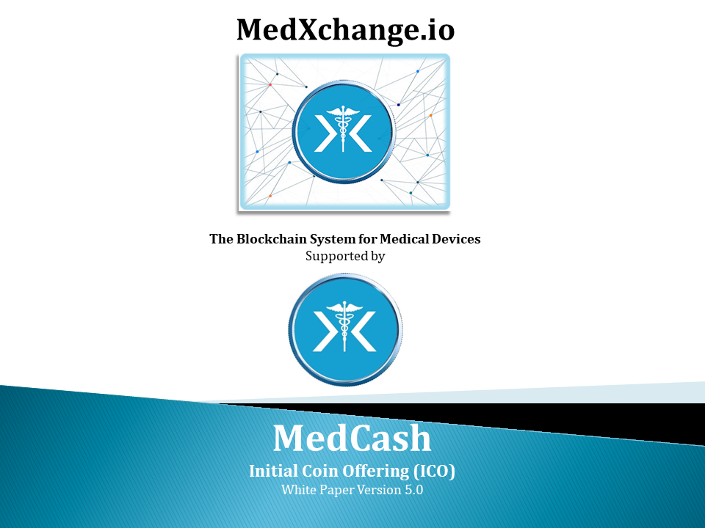

# 

# Abstract

MedXchange is a blockchain-oriented distributed system handling transactions, data transfer, payments, and data storage initially designed for medical devices, but sufficiently flexible and scalable to later add other categories of *regulated* health care ecosystems, such as pharmaceuticals, laboratory equipment, and care providers. Because of the sensitive nature and requirements of medical devices, existing blockchain distributed systems are not adequate. The goal of MedXchange is to create a permissioned blockchain system that can pass the stringent requirements of regulated medical devices by ensuring better data integrity and encryption, and by providing a validation system to ensure the miners running this network are compliant entities. MedXchange uses a Distributed Hash Table combined with an Ethereum based blockchain to provide, among many other features, the ability for frictionless data sharing and faster access to new revenue streams for sell-side users. This is accomplished via an upgrade to data integrity and security systems and the addition of an executive governance system for node validation.

The medical device industry is under major financial distress, in the United States but also globally. Many countries around the world are facing the same intensifying costs of medical devices and supplies and health care in general, as the United States and other countries are trying to address costs by reducing reimbursement rates, establishing price caps, requiring mandatory price reductions, using diagnostic related groups (DRGs), limiting funds available for medical device purchases and/or requiring inappropriate information about the product or pricing data from the manufacturer. Germany, France, Japan, Taiwan, Korea, China and Brazil are all examples of major markets where industry has reported that prices for medical devices and reimbursement rates have been potentially set lower than the value of the technology, thus limiting the introduction of advanced technologies and making it difficult for medical products to be profitable in these markets. With steeply increasing medical device costs, a secure solution for transparency and cost savings can have a massive impact on society.

The global medical device industry is primed for disruption by a technology like blockchain. The industry is, by nature, closely linked with some of the facets that distributed ledgers and smart contracts were designed to enhance. These include security restrictions, shareable data, networking, and consistent, reliable service. While traditional models of infrastructure have worked to bring the medical device industry to where it is today, many analysts see these systems as expensive, outdated, and susceptible to failure. Old technology systems that are put to the test by increasing amounts of data and stringent industry standards have not served to improve patient care, the argument goes.

This whitepaper has been prepared solely for the purpose of informing potential contributors to MedXchange with respect to a proposed technical implementation of, and architecture for, MedXchange. This whitepaper is non-binding in all respects and does not create any legal obligation of any kind on any person. The ultimate implementation of the MedXchange platform is dependent upon several factors and risks outside of the control of MedXchange Ltd., including regulatory risks, contributor participation, the adoption of blockchain technology and the continued use and adoption of the Ethereum network. Nothing in this whitepaper or otherwise shall require MedXchange Ltd. to take any steps to develop or otherwise implement the MedXchange system. MedXchange Ltd. reserves the right to abandon the MedXchange project at any time and to change the implementation of MedXchange platform contemplated by this whitepaper at any time. Prospective users of the MedXchange platform and other contributors to MedXchange are advised to contribute and/or participate at their own risk and without reliance on any statement contained in this whitepaper. This whitepaper does not constitute a prospectus or offer document of any sort and is not intended to constitute an offer of securities or a solicitation for investment in securities in any jurisdiction. MedXchange Ltd. does not provide any opinion on any advice to purchase, sell, or otherwise transact with MedCash and the fact of presentation of this whitepaper shall not form the basis of, or be relied upon in connection with, any contract or investment decision. No person is bound to enter into any contract or binding legal commitment in relation to the sale and purchase of MedCash, and no cryptocurrency or other form of payment is to be accepted on the basis of this whitepaper.

# 

# Table of Contents

Abstract 2

Table of Contents 4

Glossary 5

Introduction 7

Overview of the Medical Device Industry 9

1. The Global Medical Device Market 10

a. Introduction 10

b. Global Market Size and Key Players 10

c. A Closer Look at the United States Medical Device Market 12

d. Key Trends in the Global Medical Devices Industry 13

2. What are Medical Devices Exactly? 14

a. Medical Device Classification 15

b. Medical Device Classifications in Certain Jurisdictions 18

3. MedxChange Platform Design 19

a. MedCash (MEDCASH) Token 20

b. Governance 20

c. Smart Contract Blockchain 23

d. Data Storage 24

4. What Makes MedXchange / MedCash (MEDCASH) Unique? 28

a. Description of the Committed Use Cases – O2fast and Inspirulux 30

b. How will the Supply Chain be Disintermediated in General? 34

c. Attracting Users to MedXchange 35

d. How will the Growth of MedCash as a CryptoCurrency be Supported? 38

5. CryptoMining Operations 43

a. Electricity Supply 44

6. Our Initial Coin Offering (ICO) 46

a. Coin Allocation 46

b. ETH / MEDCASH Exchange; Bonus Tokens 46

7. Our Teams and Partnerships 47

Programming Partnerships 50

8. Roadmap 51

# Glossary

**Buy-side user**

A user of the MedXchange platform that is focused on *buying* medical devices, and will typically comprise the direct end user or patient, purchasing directly from the manufacturer or supplier without the need of a “middle man.” Buy-side users therefore comprise the hundreds of millions of patients and end-users globally needing medical devices and supplies. Buy-side Users also include care providers such as hospitals (or hospital groups), clinics, Group Purchasing Organizations (GPOs) and service providers (physicians, specialists, etc).

**Disintermediation**

Disintermediation is the removal of intermediaries in economics from a supply chain, or cutting out the middlemen in connection with a transaction or a series of transactions. There is a lot of “tolling” in the supply chain, meaning fees and markups that can be eliminated.

**Durable Medical Equipment (DME)**

Durable Medical Equipment refers to certain kinds of medical equipment or special supplies allowing patients or users to live a high quality of life and function as independently as possible. Equipment and supplies are purchased through a durable medical equipment or DME supplier. Some examples of DME include: Wheelchairs; Crutches; C-PAP machines and supplies; Oxygen; High calorie formula; Colostomy bags; Foot orthotics; Shower chairs; Hospice beds; and Breast pumps.

**Fiat**

Fiat money is currency that a government has declared to be legal tender, but it is not backed by a physical commodity. The value of fiat money is derived from the relationship between supply and demand rather than the value of the material that the money is made of. Examples include “traditional” currencies such as the US Dollar, Chinese Yuan, Japanese Yen, European Euro, Indian Rupee, and so forth.

**HIPAA**

In the United States, HIPAA stands for Health Insurance Portability and Accountability Act. Passed in 1996 HIPAA is a federal law that sets a national standard to protect medical records and other personal health information. Therefore, medical device and pharmaceutical companies are subject to HIPAA.

**MedCash**

An ERC-20 token used by users on the MedXchange platform as the exclusive cryptocurrency to conduct transactions, both in-country and globally. Ultimately, MedCash will be able to be purchased with fiat money, can be sold for fiat money, and can be traded for Bitcoin or any other cryptocurrency.

**Medical Device**

Defined broadly, medical devices are items that are used for the “diagnosis . . . cure, mitigation, treatment or prevention of disease” and are not absorbed or metabolized by the body.

**Medical Device Classification**

The United States Food and Drug Administration (FDA) categorizes medical devices into one of three classes – Class I, II, or III – based on their risks and the regulatory controls necessary to provide a reasonable assurance of safety and effectiveness. Class I devices generally pose the lowest risk to the patient and/or user and Class III devices pose the highest risk. Other jurisdictions follow similar device classifications. For example, the CE Mark (which clears a medical device for sale in the European Union) also categorizes medical devices into one of three classes – Class I, II, or III (however Class II devices are subdivided into Class IIa and Class IIb).

**MedXchange**

MedXchange is an online platform to facilitate and secure the global exchange of medical devices, supplies and payments. The system will democratize the global medical device industry by disintermediating the medical device and supplies ecosystem and making it more efficient, lowering ultimate patient/user or insurance cost in the process. While the system will initially be focused on the medical device industry, it will be sufficiently flexible and scalable to add other categories of regulated health care ecosystems, such as pharmaceuticals, laboratory equipment, and care providers.

**Over-the-Counter (OTC)**

Over-the-counter or OTC refers to medical devices or supplies that do not require a prescription to be purchased.

**Sell-side user**

A user of the MedXchange platform that is focused on *selling* medical devices, such as medical device manufacturers.

# Introduction

MedXchange represents a remarkable, global opportunity to transform the global medical device and supplies ecosystem. Using blockchain technology the MedXchange system is a global first and will provide a thriving medical device ecosystem that will drive down the cost of medical devices and supplies globally and thereby making medical care more affordable, a mission-critical goal for society. At the same time, MedXchange promises to increase margins for beleaguered medical device companies. Transactions on the system will be done with MedCash, an Etherium based (ERC-20) token used by users on the MedXchange platform as the exclusive cryptocurrency to conduct transactions, both in-country and globally.



MedXchange will accomplish its goal of reducing cost and increasing efficiency by or through:

* Disintermediation, both in-country and globally (by removing – frequently redundant or non-value-additive - layers in the medical device supply chain)
* Reducing “tolling” in the supply chain
* Increasing efficiency
* Increasing transparency
* Increasing speed to market for manufacturers and suppliers
* Allowing equipment rental models efficiently
* Allowing for a more frictionless global supply chain

Recent developments in the United States in some ways may represent a reasonably good proxy for global trends. Business as usual ended in 2013 for the U.S. medical device industry. Although it sounds dramatic, the statement is justified. The U.S. healthcare sector is undergoing massive change – thanks to a convergence of factors that include:

* A new 2.3 percent federal excise tax on medical devices that took effect in January 2013
* Intense price pressure from payers – insurance companies, corporations and government - which is shifting buying behavior and authority
* A payer-driven shift in performance requirements — from selling devices and treating episodes to delivering positive patient outcomes
* Transition from the hospital-centric care delivery model to one that is more dispersed – i.e., retail clinics, mobile care units, assisted living facilities and home health care

While these developments did not come as a surprise to the industry, they are driving medical device companies in the United States to rethink everything – including their supply chains. *MedXchange is harmonious with and will enhance the industry’s quest to drive cost out of the supply chain*. How? (i) By making it leaner using blockchain technology; and ​(ii) By removing participants from the supply chain and moving the sellers closer to buyers to lower costs (for buyers), and increasing margins (for sellers). The “tolls” involved in moving a device or item downstream will be reduced or eliminated. In addition, manufacturers and suppliers can mitigate the adverse effects of issues such as obsolescence, inventory burden, and seasonality.​ Our ​ ​system ​ ​will ​ ​provide ​ ​a ​ ​thriving ​ ​ecosystem ​ ​for ​ ​creating ​ ​a medical device and supplies​ ​marketplace, ​with the ​​goal ​​of ​​reducing the ​friction ​associated with supply chain complexity, regulatory compliance and go-to-market inertia and cost, and ​to​ ​increase ​ the financial​ ​upside​ ​for device sellers and reduce cost for customers. ​ ​This marketplace can ​ ​include ​ ​apps​ ​for ​every piece of ​ ​the​ ​medical device ​continuum ​such​ ​as​ ​healthcare facilities, ​ care providers, and insurance​ ​agencies. ​ ​The ​accessibility ​of ​the marketplace will allow for applications to ​be written​ ​for ​​local ​​scale ​or ​​globally.

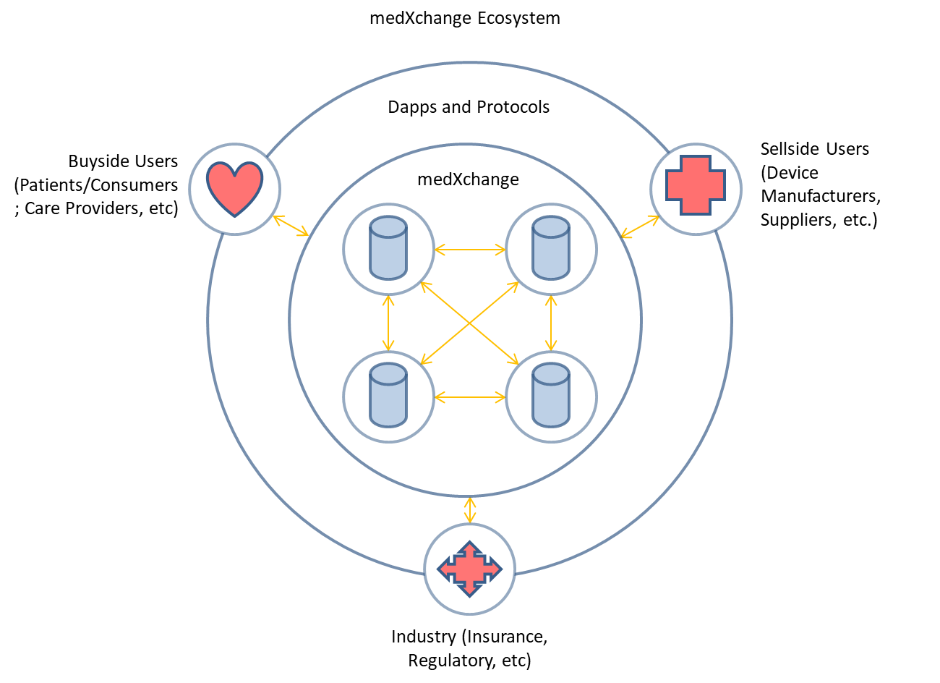

# Overview of the Medical Device Industry

The medical device industry makes an enormous number of products—ranging from surgical gloves to artificial joints to imaging equipment—and plays a crucial role in developing new medical technologies that can improve the ability to diagnose and treat illness. The industry has a relatively small number of large, diversified companies and a large number of smaller companies that are mainly engaged in research and development of new devices for specific therapeutic areas.

Medical devices play an important role in the delivery of many health care services. Defined broadly, medical devices are items that are used for the “diagnosis . . . cure, mitigation, treatment or prevention of disease” and are not absorbed or metabolized by the body. The term applies to everything from common medical supplies such as latex gloves and syringes to advanced imaging equipment and implantable devices such as cardiac defibrillators. The medical device industry is thus an important component of the larger health care system and plays an essential role by developing new medical technologies that can improve the ability to diagnose and treat illness.

Like prescription drugs, medical devices are generally regulated in most countries around the globe, such as for example by the Food and Drug Administration (FDA) in the USA. However, the regulatory framework that the US Congress has established for medical devices is less stringent in many respects, due in part to underlying differences between medical devices and prescription drugs. Most low-risk devices can be marketed without prior FDA review, and most medium-risk devices are required to demonstrate only that they are “substantially equivalent” to an existing device before being marketed. Very few devices must demonstrate that they are safe and effective before being marketed. The FDA’s surveillance of devices after becoming available to the public has also been limited historically, although improvements are being made through initiatives such as requiring unique device identifiers (UDIs) on all devices.

The market dynamics for medical devices can vary greatly depending on the device. Markets for conventional devices such as surgical gloves and other routine surgical supplies are more competitive; companies compete heavily on price and often need high sales volumes to be profitable. In contrast, markets for advanced products like implantable medical devices involve opaque pricing, are harder to enter, and are less competitive, which allows device companies to charge higher prices.

Regional and local specificity exists when it comes to payors and how payment for medical devices is achieved. Generally, the patient or end user pays, or a third party payor such as private, employer or government insurance payor pays, or a combination of these. Patients or users who are the sole payors (i.e. no third party payor or insurance involved) belong to what is often referred to as the “cash pay” market. Either way, payment is made usually directly to the supplier for of the device. However, in the United States, Medicare pays for medical devices indirectly by reimbursing providers when they use devices in the course of delivering care to beneficiaries.[1] Medicare bundles the average cost of medical devices into its overall payment rate for many services, giving hospitals, for example, an incentive to use lower cost devices.

# The Global Medical Device Market

## Introduction

The global medical devices market offers a remarkable opportunity for MedXchange to introduce efficiency, transparency, export competitiveness and cost reduction to the ecosystem. This will in turn make medical equipment more affordable to those in need, especially as population aging advances in all global markets. MedXchange can create new and sustained export opportunities for cross-border trade of medical devices by removing or diminishing market access barriers, and helping regional firms anywhere to capture a larger share of the world market.

Aging populations worldwide, coupled with extended life expectancy, create a sustainable demand for medical devices. As elderly populations’ healthcare is frequently government-subsidized in markets around the world, *home healthcare is also becoming of increased importance*, as related technologies become more effective, and healthcare budgets are more closely scrutinized. Significant and sustained downward pressures on reimbursement rates continue to eviscerate margins for medical device companies. Sustained increases in insurance rates continue to place access to much needed medical equipment out of reach of end users (frequently causing adverse effects on patient quality of life and even death). These factors combined create an unsustainable situation.

## Global Market Size and Key Players

The USA represents the largest medical device market in the world.[2] The major U.S. medical device companies include: Baxter®, Beckman Coulter®, Becton Dickinson®, Boston Scientific®, GE Healthcare Technologies®, Johnson & Johnson®, Medtronic®, St. Jude Medical® and Stryker Corporation®, to name a few

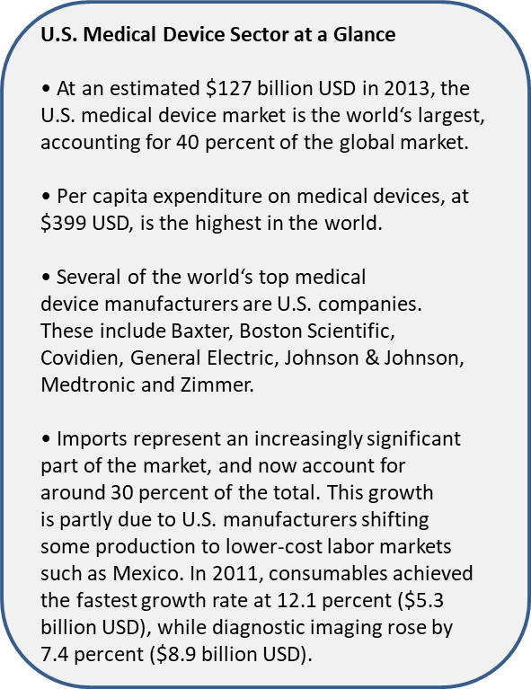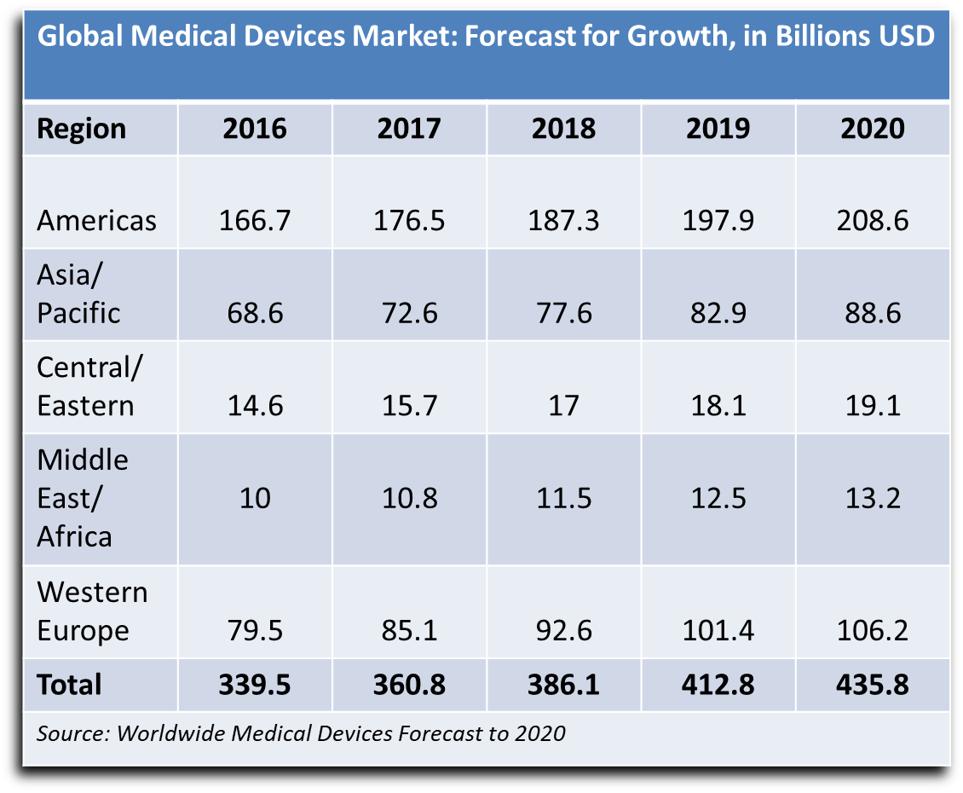

Outside of the USA market, sell-side manufacturers include companies such as Siemens® and Braun® in Germany; Hitachi®, Medical Corporation® and Toshiba® in Japan; and Philips Electronics® in the Netherlands. In addition, lower-cost manufacturers from China, Brazil, Korea, Taiwan, Mexico and India are all building up their domestic operations and beginning to compete globally.

The list of the 10 largest global medical device companies, by 2015 revenues is as follows[3]:

|  |  |  |  |  |  |  |
| --- | --- | --- | --- | --- | --- | --- |
|  |  |  |  |  |  | **2015** |
|  |  |  |  |  |  | **Global Medical** |
|  |  |  |  |  |  | **Device Revenue** |
| **Rank** |  | **Company** |  | **Country** |  | **(in USD Billions)** |
|  |  |  |  |  |  |  |
| 1 |  | Medtronic |  | United States |  | $27.7 |
| 2 |  | Johnson & Johnson |  | United States |  | 27.5 |
| 3 |  | GE Healthcare |  | United States |  | 18.3 |
| 4 |  | Baxter International |  | United States |  | 16.7 |
| 5 |  | Siemens Healthcare |  | Germany |  | 15.8 |
| 6 |  | Becton Dickinson |  | United States |  | 12.3 |
| 7 |  | Philips Healthcare |  | Netherlands |  | 11.2 |
| 8 |  | Cardinal Health |  | United States |  | 11.0 |
| 9 |  | Abbott Labs |  | United States |  | 10.1 |
| 10 |  | Stryker |  | United States |  | 9.7 |

Note: Some companies shown in this table, such as Johnson & Johnson, generate substantial revenues in industries other than medical devices; the figures for these companies are for their medical device divisions only. Figures for Medtronic and Becton Dickinson reﬂect their acquisitions of Covidien and CareFusion, respectively. Since its acquisition of Covidien, Medtronic has been headquartered in Ireland for tax purposes.

## A Closer Look at the United States Medical Device Market

Recent studies by the Congressional Research Service (CRS), BMI Research, and the Advanced Medical Technology Association (AdvaMed, the industry’s main trade association) have estimated that total U.S. spending on medical devices was $119 billion in 2011, $127 billion in 2013, and $166.7 billion in 2016 respectively.[4] These estimates indicate that medical devices account for roughly 4 percent to 6 percent of total U.S. spending on health care. The AdvaMed study also found that the share of total U.S. spending on health care devoted to medical devices has changed very little over time, suggesting that spending on medical devices has grown at about the same rate as the broader health care sector.

Estimates of the total number of companies and employees in the medical device industry also vary somewhat. According to two studies that used data from the US Census Bureau, there are roughly 5,300 to 5,600 U.S. companies in the industry, with approximately 330,000 to 365,000 employees.[5] Medical device companies are located throughout the United States, but the industry has a larger presence in California, Massachusetts, and Minnesota. However, most of the companies in the medical device industry are relatively small. One study that analyzed economic data from the Census Bureau found that 73 percent of medical device firms had fewer than 20 employees and that 88 percent had fewer than 100 employees.

These figures suggest *that companies with fewer than 100 employees account for roughly 15 percent to 20 percent of total employment in the medical device industry*. CRS found a similar pattern when it looked at corporate tax return data for U.S companies whose primary activity is making medical supplies and equipment: 83 percent of companies had less than $1 million in assets, and 95 percent had less than $10 million in assets (Gravelle and Lowry 2015). These smaller companies are engaged primarily in the development of new medical technologies and are often focused on relatively narrow therapeutic areas.

MedXchange will allow any and all these sell-side participants in the global medical device ecosystem to compete and have immediate access to millions of buy-side customers directly, without the need for intermediaries, distributors, wholesalers, or retailers. This can be the case for home markets and cross-border markets. Where a particular device or item is represented by just one sell-side player a one-to-many situation arises. Where multiple sell-side competitors represent the same or similar devices a many-to-many situation may arise. Either way, MedXchange will fundamentally change the way medical devices are deployed worldwide.

## Key Trends in the Global Medical Devices Industry

### Cost Efficiency

Cost, cost, cost. It’s all about cost. The relentless drive to reduce cost while maintaining margins has caused a shift towards value-based healthcare in the United States. By addressing therapies as an all-inclusive treatment package, medical device companies believe they can better assist providers in delivering on their obligations to patients, controlling costs and simplifying transactions. However, a large portion of cost remains in the equipment and devices themselves and can be removed through the disintermediation process offered by MedXchange and by removing “tolling” as the product moves downstream.

### Changes to Export Market Mixture

Traditionally large markets for medical devices such as the European Union (EU), Japan and Canada have matured and therefore have relatively low (3 to 5 percent) annual growth rates. In contrast, demand for medical devices is growing at double digit growth rates in developing countries. Significant yet underserved populations in developing markets often grow steadily, face similar aging populations and increasing lifestyle diseases and have an increased awareness of health technology development. Furthermore, many markets deemed as “developing” have highly urbanized population centers with rising expendable wealth, making certain sectors of markets interesting to medical device exporters. MedXchange will allow Sell-side Users to easily, quickly and cost-effectively access these rapidly growing markets.

### Consumer-Driven Decision Making

Hospital administrators and patients will increasingly make the decisions about these products. Consumers will play a bigger role in healthcare decisions and choices, reﬂecting a switch in mindset from being “patients” to “consumers.” Armed with greater access to product information, patients are better informed about drugs, products, devices, procedures, treatment options and healthcare providers. As a result, they are exercising a greater degree of control over their healthcare decisions, particularly in developed markets.

**“Consumers will play a bigger role in healthcare decisions and choices, reflecting a switch in mindset from being “patients” to “consumers”**

### Regulatory Convergence

There is a concerted push towards international convergence and harmonization of global regulatory standards. To that end, the Global Harmonization Task Force (GHTF), formed as a voluntary organization comprised of regulators and industry with five founding members consisting of the United States, Canada, Japan, the European Union and Australia, had as its core objective streamlining and harmonizing regulatory standards. Developing countries like India, China, Mexico and Brazil benefited in the work of GHTF by considering that organization’s guidance documents while designing their own regulatory systems.

Many countries are also implementing requirements for medical devices – in the form of requiring a unique device identifier (UDI). In the case of the U.S. requirements, the intent is to improve the ability to capture medical device adverse event reports, as well as device performance data. This serves two purposes: it enables regulatory authorities to identify product problems more quickly, better target recalls and improve patient safety; and, it facilitates product performance tracking. The latter is increasingly important to governments and healthcare payers.

To comply with such regulations, the medical device industry, and all parties in the supply chain, must adopt rigorous serialization protocols and track products through the supply chain, normally by applying a unique identifier at the individual product unit rather than at lot level. This significantly increases the burden for scanning and tracking product, maintaining and sharing collected data, and protecting product integrity and the chain of custody throughout the entire supply chain. We believe that the simplification of the supply chain will become an imperative and a strategic advantage for device manufacturers to reduce the complexity – and therefore cost, of complying with these new regulations, in addition to reducing the delivered cost of devices to the customer.

# What are Medical Devices Exactly?

A ‘Medical Device’ is defined as follows:[6]

‘Medical device’ means any instrument, apparatus, implement, machine, appliance, implant, reagent for in vitro use, software, material or other similar or related article, intended by the manufacturer to be used, alone or in combination, for human beings, for one or more of the specific medical purpose(s) of:

* diagnosis, prevention, monitoring, treatment or alleviation of disease,
* diagnosis, monitoring, treatment, alleviation of or compensation for an injury,
* investigation, replacement, modification, or support of the anatomy or of a physiological process,
* supporting or sustaining life,
* control of conception,
* disinfection of medical devices,
* providing information by means of in vitro examination of specimens derived from the human body;

and does not achieve its primary intended action by pharmacological, immunological or metabolic means, in or on the human body, but which may be assisted in its intended function by such means.

**Note**: Products which may be considered to be medical devices in some jurisdictions but not in others include:

* disinfection substances,
* aids for persons with disabilities,
* devices incorporating animal and/or human tissues,
* devices for in-vitro fertilization or assisted reproduction technologies.

An ‘In Vitro Diagnostic (IVD) Medical Device’ is defined as follows:[7]

‘In Vitro Diagnostic (IVD) medical device’ means a medical device, whether used alone or in combination, intended by the manufacturer for the in-vitro examination of specimens derived from the human body solely or principally to provide information for diagnostic, monitoring or compatibility purposes.

**Note 1**: IVD medical devices include reagents, calibrators, control materials, specimen receptacles, software, and related instruments or apparatus or other articles and are used, for example, for the following test purposes: diagnosis, aid to diagnosis, screening, monitoring, predisposition, prognosis, prediction, determination of physiological status.

**Note2**: In some jurisdictions, certain IVD medical devices may be covered by other regulations.

## Medical Device Classification

There are generally three regulatory classifications of medical devices: Class I, Class II and Class III in most jurisdictions. In the United States the classifications are assigned by the risk the medical device presents to the patient and the level of regulatory control the FDA determines is needed to legally market the device. As the classification level increases, the risk to the patient and FDA regulatory control increases. Accessories to medical devices, devices used with a medical device to support use of the device, are considered the same classification as the medical device. In Europe for example, device classifications follow similar guidelines based on risk. With the advent of regulatory convergence many countries are moving to the same or similar frameworks for classifying and regulating medical devices.

The FDA classification of medical devices is based upon classifications for devices currently legally marketed in the United States. The FDA determines the device classification by the device’s intended use and the risk the device presents to the patient. New medical devices are compared to legally marketed medical device classifications with the same intended use and technological characteristics to determine the device classification.

### Class I Medical Devices

Class I medical devices have the least amount of regulatory control. Class I devices present minimal potential harm to the user. Class I devices are typically simple in design, manufacture and have a history of safe use. *Examples of Class I devices include tongue depressors, arm slings, nasal inhalers, nebulizer pumps, contact lenses, ultrasound scanners and hand-held surgical instruments*. Most Class I devices are exempt from the premarket notification and may be exempt from compliance with the good manufacturing practices regulation. According to the FDA, ***47% of medical devices fall under this category*** and 95% of these are exempt from the regulatory process.[8] Further, most ***Class I devices can be sold / purchased over the counter (OTC) without the need of a prescription*** (as long as the device meets the exact definition of the Class I intended use).

The following visuals are examples of Class I devices or supplies:

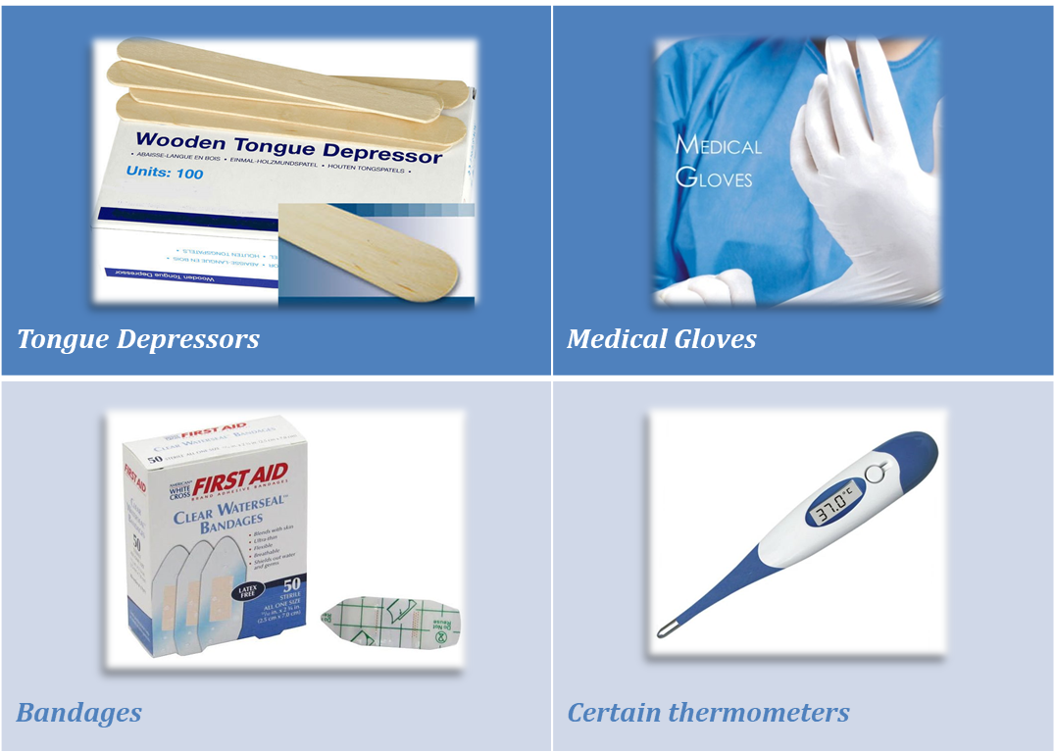

### Class II Medical Devices

Class II medical devices are devices where General Controls are not sufficient to assure safety and effectiveness and existing methods/standards/guidance documents are available to provide assurances of safety and effectiveness. In addition to compliance with General Controls, Class II devices are required to comply with Special Controls. Special Controls include:

* Special labeling requirements,
* Mandatory performance standards, both International and United States
* Postmarket surveillance
* FDA medical device specific guidance

Class II devices typically require pre-market notification by submission and FDA review of a 510(k) clearance to market submission. A few Class II devices are exempt from the premarket notification. *Examples of Class II devices include oxygen concentrators, emergency oxygen, hypodermic needles, powered wheelchairs, some pregnancy test kits,* *physiologic monitors, x-ray systems, gas analyzers, pumps, and surgical drapes*. According to the FDA, ***43% of medical devices fall under this category***.[9] Further, ***Class II devices are generally a mix between OTC and prescription devices***.

The following visuals are examples of Class II devices or supplies:

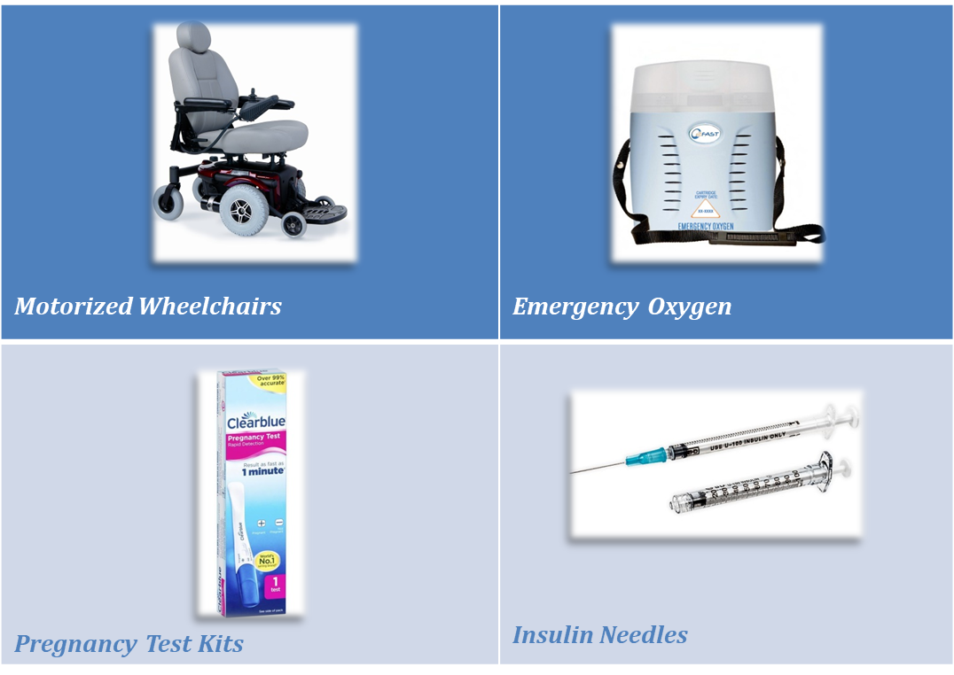

### Class III Medical Devices

Class III medical devices have the most stringent regulatory controls. For Class III medical devices, sufficient information is not available to assure safety and effectiveness through the application of General Controls and Special Controls. Class III devices usually support or sustain human life, are of substantial importance in preventing impairment of human health, or present a potential unreasonable risk of illness or injury to the patient. Typically a Pre-Market Approval (PMA) submission to the FDA is required to allow marketing of a Class III medical device. A few Class III medical devices are required to only have a 510(k) cleared by the FDA to be marketed. *Examples of Class III devices that require a PMA are: replacement heart valves, implantable pacemakers, orthopedic implants, hemodialysis machines, coronary stents, silicone gel-filled breast implants, and implanted* *cerebella stimulators*. According to the FDA, ***10% of medical devices fall in the Class III category***.[10]

The following visuals are examples of Class III medical devices:

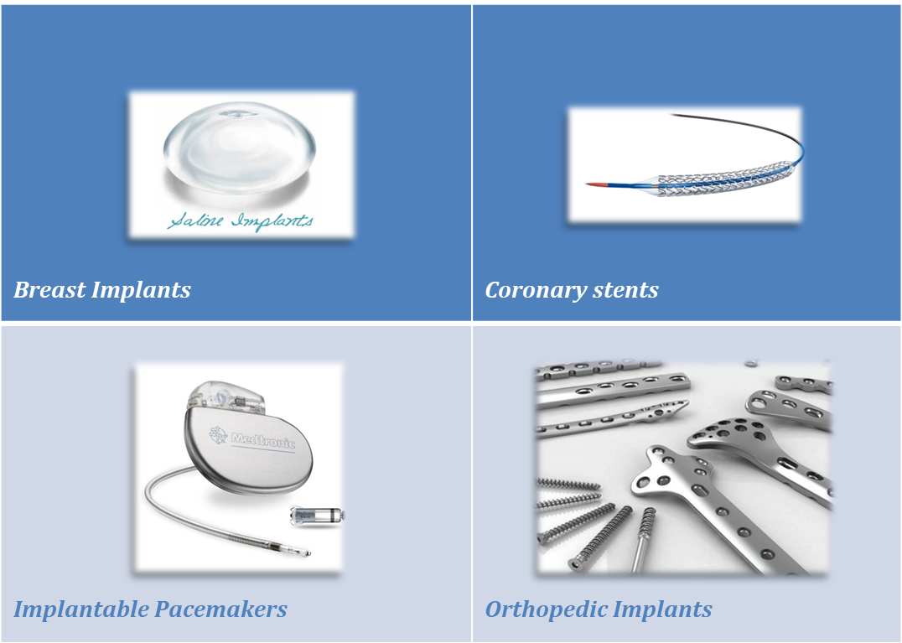

## Medical Device Classifications in Certain Jurisdictions

Most other countries follow similar device classifications. For example:

|  |  |
| --- | --- |
| USA: | Canada: |
|  |  |

# MedxChange Platform Design

MedXchange is a dual system platform utilizing a: (i) Blockchain protocol for transactions, identity and smart contracts, and (ii) a distributed hash table (DHT) for data storage, managed by a governance system. The Blockchain protocol will be based off of the Ethereum network, and will start with proof of stake[11] (i.e., Casper) and govern the data storage sites. However, MedXchange proposes to create a permissioned blockchain with high security and public access to transact keys, tokens, smart contracts. There are other consensus mechanisms that we are investigating that will be researched in conjunction with the development of the system and may be adopted after a vote via the governance protocol at a later time. The MedXchange permissioned system implements several major modifications to the Ethereum protocol, such as: the ability to store identity on the network, a government system that allows for upgrading and validation, and interactions that are built in to allow for communication with the DHT. The DHT will also use a new system to verify valid storage and miner nodes, keeping track of identity and data access, and negotiate cost of storage through the Blockchain protocol.

The currency of our system, MedCash (MEDCASH), will be what is used to transact on the system. Buy-side Users on the system will purchase all their medical devices and supplies using MedCash, and Sell-side users will require payment in MedCash. MedCash will also be the currency that funds the miners and data silos. The currency can also be used to activate smart contracts or trade for keys. The goal of this design is to create a blockchain system that can pass the stringent requirements of medical devices and healthcare in general by ensuring better data integrity and providing a validation system to ensure the miners running this network are compliant entities. In the following sections we will go through the details of the blockchain system, the decentralized database, the governance system, and finally, system specifics.

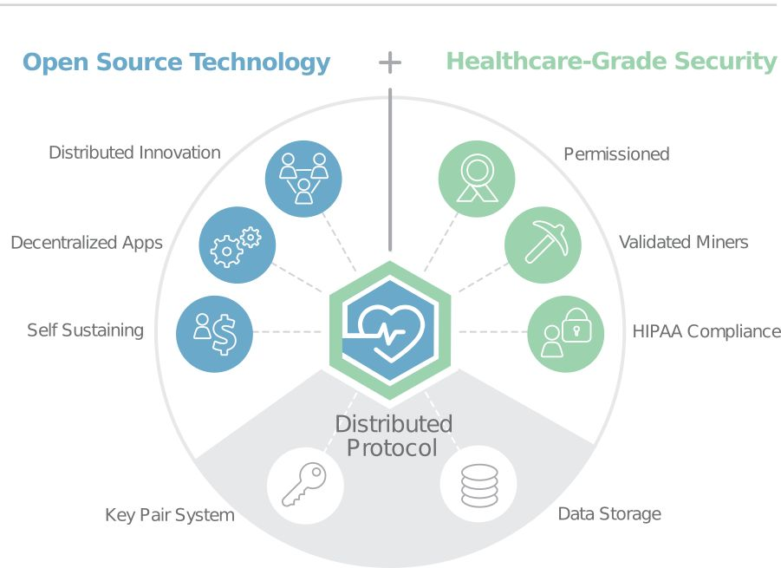

**MedXchange Blockchain Protocol**

In addition, we will be providing immediate usability in the form of a smart contract market place. This marketplace will allow for the creation, management, buying, selling, and sharing of permissioned keys that will allow access to off-chain data. This design will allow users to use the MedCash (MEDCASH) tokens to manage their data via the blockchain immediately and provide an additional proof of concept tool for device manufacturers and care providers.

## MedCash (MEDCASH) Token

There are several benefits to establishing a new token. Due to the strict regulations around privacy and security in the global medical device industry, certain processes and data sharing capabilities will need to be run on a dedicated Blockchain system. As such, there would be several interoperability issues if another currency is used. Other currencies, such as Zcash or Etherium, would not be able to function appropriately with a HIPAA-compliant system and medical devices to achieve its maximum value due to its openness and lack of governance.

With a focus on security at the core, the MedCash (MEDCASH) token will also be able to:

1. Provide a transaction currency that allows Buy-side Users and Sell-side Users the ability to buy and sell medical devices in real time;
2. Reward miners/validators and data storage devices that run our ecosystem; and
3. Provide an extra incentive for early adopters of the platform.

As previously stated, all users will need the token to be able to purchase products in the system, to transfer permissioned keys giving access to off-chain data, and to access smart contracts and data storage space. This will all involve the purchasing of the MedCash (MEDCASH). The MedCash (MEDCASH) token will be used by the users involved in the transaction and used to pay node fees for running the network. The only way to earn the MedCash (MEDCASH) tokens, without buying or trading for them, would be to operate a node on the network and receive payments from running the network.

As mentioned previously a percentage of the MedCash (MEDCASH) tokens will be set aside to help accelerate adoption by already existing entities. To entice medical device manufacturers to adopt our platform, we are using a similar system that Paypal and GUP successfully used, which will include a referral program.

## Governance

In the United States medical records are protected by HIPAA (other jurisdictions have similar systems or are adopting similar systems to protect patient privacy). HIPAA compliance and the extra security needed by participants in the regulated medical device ecosystem requires a new governance model. This new governance model requires special privileges to be granted to the governing consortium in the form of executive user IDs, which will be in the form of MedCash (MEDCASH) tokens. This will create a permissioned blockchain with high security and public access to transact keys, tokens, smart contracts. These user IDs will allow these users to give out other special user privileges, also in the form of executive tokens. Any base account can trade tokens, activate and add smart contracts and add data and keys to the system; however, the only users who can allow new nodes to join the Blockchain service, join the data storage service, or push updates, are the entities with executive IDs.

To ensure a robust network with no middlemen, there are several ways to attain executive ID to join the governing consortium. Initially, MedXchange and any major partners who have volunteered to perform this mission will have their executive IDs seeded in the genesis block. After that there are several primary ways:

1. An existing consortium member may issue you an ID, given there is 60% approval from the other consortium members
2. An existing consortium member may propose a new member, and the validators and consortium members, approve of it with a simple majority and no quorum
3. Validators may propose new consortium members with a simple majority

In addition, an executive ID may be taken away. They may be taken away when either a stakeholder or consortium member submits a proposal and a certain percentage of the consortium vote and a certain percentage of the stakeholders with 51% of quorum. Medical device companies, care providers and patients will likely not be comfortable with either storing their data on public servers or allowing public servers to perform these computations. Therefore, the governing consortium will provide a verification / audit service. This verification service will involve the governing consortium checking that the entities running servers are currently HIPAA certified and that the entities are active administrators checking for their nodes. In case there is a breach, the consortium can quickly push an update to fix the breach and in addition since the data is not directly stored on the blockchain but on an encrypted database, the data will remain unaffected.

Once certified they will be issued a Provider ID, which will allow them to create a miner node and a data storage node, and in addition create more provider IDs attached to their entities. Meanwhile the governing consortium will keep track of these users and ensure that they are meeting compliances. Should a provider fail the compliance check their key will either be allowed to expire or the entity that granted them the key may take it back. In addition, in case of a large breach, other members can vote to have the permission taken away with a 60% positive vote. While there are several other models we have considered, including public servers or having a GNT inspired validation system, this system will need to be run on a permissioned blockchain, which our governance model will allow for. This need is due to current HIPAA requirements and the current status of the providers. It will remain open to the public to use, but only validated entities will be allowed to operate it.

A simple diagram illustrating the governance model follows:

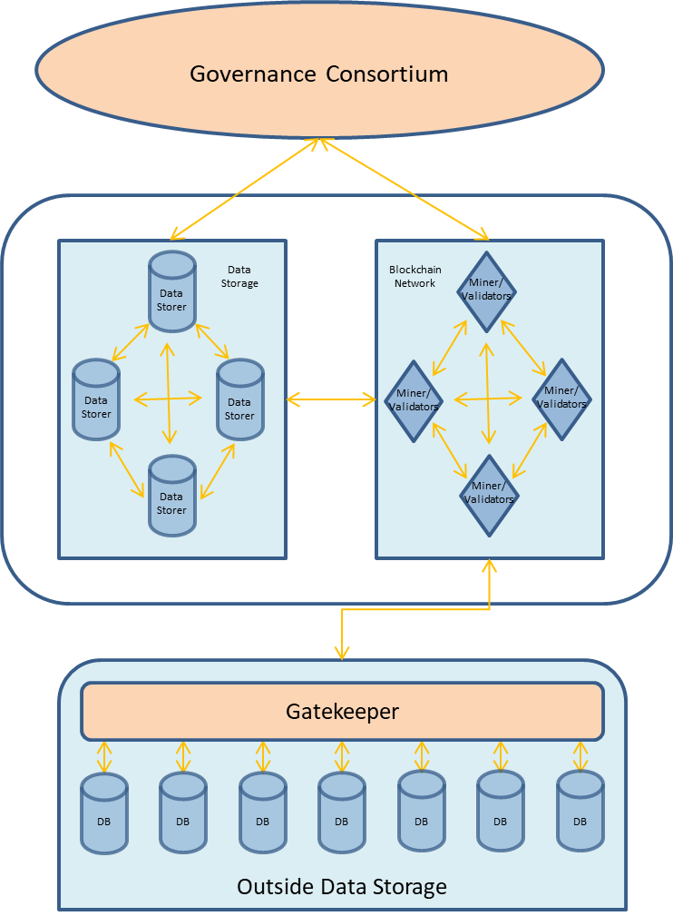

For updating, all update changes will be proposed by the governing consortium which will have to have their special executive ID in their wallet to propose a change. These changes will take place over an election cycle that will last a certain number of blocks. This time length can be changed in future updates. During this period, the update process is broken up into four periods. In the first period, updates are proposed to the network and stakeholders are allowed to vote on it for approval. In the second period, the update with the most approval will go to vote again with the votes either being a yay, nay, or abstain. During the third quarter, if the vote was approved the updated protocol replaces the protocol in testing. Finally, after running for the entire third session, the update is voted on one last time before being pushed forward. There are a few things that should be noted: This system will currently not require any quorum for the majority of the decisions. That is due to the potential lack of responsiveness on behalf of the network in non-tech related fields. Quorum will be further evaluated, and may be added later.

Should nothing be approved during the second period, the first period immediately restarts. Additionally, in cases of emergency, should the governing consortium find a critical bug or malicious code, the governing consortium can immediately push an update with a positive vote of 60%. This is the current method, and is due to the critical nature of the data being provided. This may change during testing or via an update.

One potential issue with this system is that a consortium member could try to add miners to the system to try to seize control through a 51% attack. To defend against this attack, should a consortium member try to add more than a certain percentage of new miners to a network, then there will be a vote of approval from among the consortium members to grant that increase.

The governing consortium is not a middleman and all individuals will be allowed to interact with the chain; however, due to the sensitive nature of this system the governing consortium will be needed to help maintain the system and provide verification. As such the governing consortium members may charge fees individually for verification and update its purpose solely to the miners, who will be making a profit off of mining these blocks.

## Smart Contract Blockchain

The MedXchange blockchain protocol and the MedCash (MEDCASH) token is based on the Ethereum protocol, which is an open source blockchain with distributed computing for smart contracts. Smart contracts are state-based, immutable programs stored on the blockchain, which can guarantee the contract’s actions.

In our own permissioned blockchain, we have added a few modifications on top of Ethereum:

1. Similar to our data storage nodes (which are detailed in following sections), miners/validators will be certified ahead of time and will be sent a special node ID to their node address to certify them.
2. The next difference from Ethereum is the ability of the user to transfer our token, MedCash (MEDCASH), along with several other types of data like permissioned key pairs for data access. The user will be able to store their public identification keys, and any other keys they generated, to access or edit their data. These keys allow access to their data through the use of special gatekeepers that will either be a special authentication server, which sits in front of the data, or the blockchain system itself if a distributed data storage system is proven effective. A user will also be able to store the key used to certify miners/validators and data storage nodes, these keys will given out by the governing consortium and will act as a whitelist, as further detailed in the governance section. This whitelisting system is specifically designed to meet the privacy requirements / compliance such as those of HIPAA. The whitelist exists to focus on healthcare security compliance.[12]
3. The third major difference is that a user will be able to store a contract state for their data storage node if they are a MedXchange data storage center, as further detailed in the data storage section. In the upcoming sections we will discuss these specifications in more technical detail as well as touch on other main aspects of our blockchain technology.[13]

### Accounts

In MedXchange, like Ethereum, our state on the blockchain is made up of objects. We have the 4 fields mentioned in Ethereum which are the nonce, crypto currency balance, contract code, and storage. In addition, we will have a key storage section along with a valid miner/storer ID and an executive ID. These will allow users to keep track of their identities and their ability to mine or store data. MedCash (MEDCASH) is the fuel of this network, and is used to pay transaction fees, fuel smart contracts, and provide liquidity to medical data and identities stored in the system. In addition, there are two contracts with which a user will interact: the first is similar to its counterpart on the Ethereum network, the other is a data storage contract, which will use its contract field to handle the data storage account in a safe and migratable manner.

### Messages and Transactions

Within the MedXchange system, transactions on the blockchain protocol will function very similarly to the Ethereum network with a recipient, signature, amount of MEDCASH, optional data field, STARTGAS, and GASPRICE.

Messages are also very similar to their Ethereum-based counterpart and contains the same fields, which include the sender, recipient, amount of ether, optional data field, and STARTGAS value, are sendable only as contracts, and exist only in the execution environment.

In addition, we are looking into either adding in an identity field for trading identities or keeping that in the optional data field for Message and Transactions.

### Distributed Consensus

Our system will start out by utilizing proof of stake. We will continue to assess further updates to our system based on methods listed in the future section, which will include systems using proof of burn and proof of authority, based on available resources.

## Data Storage

Our database system will utilize a Distributed Hash Table (DHT) to manage a specially modified Kademlia table to securely store data with it being based on the system explained in Storj. In this section, we describe in more detail our data storage section with our intention being to start with a system based off Storj and make changes to make it useable by the medical device industry. In a subsequent phase, we will release a supplemental white paper that will detail the system and necessary changes. We will write a supplemental white paper because our development of our distributed data storage system will be further in our development plan and new techniques may have emerged by then.

### Signature for Data Storage

For nodes to send messages back and forth to each other, much like S/Kademlia, they have to sign their messages. When joining the network, a node creates an ECDSA key pair, a public and private key, with the Node ID corresponding to a hash of the public key. This Node ID also corresponds to its MedCash wallet address. Its public key will also be assigned to this address in the wallets identity system. A node will sign every message before sending the message out, and the retrieving nodes will verify that message in turn by checking the wallet address for a storage node token. This upgrade greatly increases the security of the system by helping to prevent eclipse attacks and ensuring only verified miners can take part. It also allows an individual to make requests to individual storage nodes for specific security situations.

### Data Storage Contracts

The storage of data is negotiated via state channels and stored via smart contracts on the Blockchain. These contracts will be standardized with the same API and function calls, and will hold basic data necessary for all aspects of the relationship between the data store and the user. Both sides should store this information, and we will plan on allowing them to store this on the Blockchain to provide continuous auditing.

We plan to have an automated subscriber market place for this system. This system will be built in by modifying the Kademlia DHT. A partially filled contract for every node will be stored as a smart contract attached to the node’s wallet ID. This partially filled contract contains all the information on the data storage provider and what they are charging. This value can also be easily updated by the data storage provider by pushing to their smart contract on their chain. As such, when the DHT is being formed or updated the lookup code for the partially filled out smart contract is added. For a user to find and negotiate this contract they can proceed through the DHT table while pinging the blockchain network for information on the smart contract. When a contract with the appropriate parameters is found, the user may either accept the contract and route the appropriate payment to the contract to be given to the wallet address or may counter offer a second set of parameters for the contract for the database owner to decide on. The database owner may then accept, decline, or continue the negotiation via the negotiating mechanisms. Once the contract is decided, the contract is finalized and activated giving the user the ability to use the given storage space. This is a newer system and we believe that it will provide both better latency and a better data storage market place than the currently used Quasar method,[14] which utilizes Bloom filters.[15]

Our goal is to start off by using the existing system, based off Storj, then work on this new approach. An additional service may also come later. Since all the miners’ contracts are located on the blockchain and associated with a certain data storer permissioning ID, a consortium member or user could create a market place by constantly reading through the chain and checking on the current statuses.

### Payments

Buy-side and Sell-side Users will use MedCash (MEDCASH) for transfer and payments. There are several other ways to configure for payments. A user can request that audits or partial audits be paired with their payments to ensure proper storage by submitting said request to a member of the governing consortium who has agreed to the service. To help secure that, future areas of research will be done to create permissioned keys for performing audits to insure compliance. In addition, we will be looking into state channels, as previously mentioned, in the future. State channels would allow the user and data storage to communicate and handle payments directly lowering the amount of stress put on the MedXchange system.

### Data Storage

### 

### Redundancy

In addition to the built in redundancy systems, we will be continuing to trial new error correction codes, such as Bose–Chaudhuri–Hocquenghem (BCH) and should they be found to be reliable, will either replace the old method or be added as an option to switch to. In the meanwhile, we will start with the same Reed-Solomon[16] protocol as StorJ does.

### Future Areas of Research

Blockchain is rapidly evolving and we intend to keep close tabs on developments. However to ensure the long term decentralization of the MedXchange blockchain system our goal is to let the community and fellow consortium members continue upgrading the system in the future. The following sections discuss examples of areas we are interested in researching as we progress:

#### Contract Code Execution

We will look into slight changes to the protocol to handle the potential downside of a Turing-complete script, which is that the number of potential steps for a script is unbounded. We will specifically be looking into how Tezos proposes dealing with this problem.[17] To solve this issue, a cap on the maximum number steps for a contract to run on a single transaction will be issued. This cap will be updateable through the governance system in the future. If a contract needs more steps, prior to an update, it may simply continue the contract by performing it in multiple transactions. This will help to prevent denial-of-service attacks via CPU usage.

#### Proof ​of ​ ​Stake ​ ​with ​ ​Proof ​ ​of ​ ​Burn

A ​​modified ​version ​of ​​proof ​of ​stake ​with ​proof ​of​ ​burn​ ​has​ ​been ​suggested​ ​by Tezos ​ ​that ​ ​shows great ​ ​promise.[18] ​ ​​​Proof ​of​ ​burn​ ​requires ​​miners ​to ​burn ​their ​own ​currency ​ ​and prove ​​that ​they did. ​ ​​This ​is ​​expensive ​​for ​the​ ​miner, ​​but ​spends ​no​ ​extra ​resources ​ ​than ​the ​burned​ ​assets. ​​If Tezos’ ​​system ​proves ​​more ​efficient ​we ​plan ​on ​​adopting ​​their ​ ​version ​or ​something ​similar ​​after initial ​testing.

#### Proof ​of ​ ​Authority

In​ ​proof​ ​of ​authority, ​certain​ ​nodes ​are ​granted ​the​ ​ability​ ​to ​contribute​ ​blocks​ ​and ​ nodes​ ​vote​ ​on which ​block​ ​to ​be​ ​added ​to ​​the ​chain. ​ ​​With ​the ​extra​ ​level ​of ​trust ​on the MedXchange​ ​permissioned ​system this ​consensus ​​protocol ​​will ​​have ​a ​higher​ chance ​of ​success. ​​​ ​However, ​​it ​​does ​not currently ​have ​a ​proven ​track​ ​record, ​as ​such ​​more ​research ​ and ​testing ​will ​​have ​to ​be ​done. In ​addition ​this ​change​ ​would ​​not​ ​take ​place ​​till ​after ​the ​ full ​​distributed ​​system ​is ​launched​ ​that way ​​it ​​may ​​be​ ​put ​to ​a ​vote​ ​to ​the ​governing ​ consortium ​​to ​insure​ ​the ​​solution ​is ​​supported ​​by the ​community.

#### Oracles

Oracles ​can represent a ​remarkably useful​ ​technology ​to​ ​push ​data ​to​ ​the ​ ​blockchain ​ ​and ​ ​we ​ ​are ​ partial to ​ ​integrating them ​into the MedXchange ​system. ​

### Attacks

Due to privacy issues and the overall sensitive nature of information in the medical device ecosystem we discuss ​recent​ ​examples ​​and ​​new ​​techniques ​​that ​the MedXchange ​ system ​will provide ​over and above ​current blockchain ​fixes.

#### Ransomware

As shown ​via ​​WannaCry, ​ransom ​ware ​can ​be ​a ​massive problem for “traditional” legacy (non-blockchain) systems.​​ ​By ​storing ​their ​data ​and ​​apps ​on ​secure, ​redundant and immutable ​systems, medical devices users from the manufacturer down to the end user can​ ​prevent​ an​ ​attack ​​like Wannacry ​from ​​happening. ​ ​​In the event that ​their ​personal​ machines​get taken ​down ​they ​can ​​just ​simply ​​access ​our ​system through other secure devices ​​and ​continue to ​​operate. ​ We believe therefore, that MedXchange is ​uniquely ​suited ​​to ​mitigate ​with ​​this ​risk.

#### Identity ​hijacking

Identity ​ ​hijacking,​ ​which ​is​ ​where ​a ​node's​ ​ID ​is ​ ​stolen, ​ ​is ​ ​prevented ​ ​by ​ ​requiring ​ ​all ​ ​the Node IDs ​to ​be ​public ​key ​hashes ​and ​requiring ​all ​messages ​to ​be ​signed. ​​This ​ approach ​ ​will prevent ​a ​malicious ​agent ​from ​impersonating ​any ​other ​node.

#### Sybil Attacks

In ​a ​Sybil ​attack, ​the ​malicious ​entity ​gains ​a ​large ​amount of ​influence ​on ​the ​system ​by creating ​a ​large ​number ​of ​fake ​nodes. ​​Along ​with the ​traditional ​mechanism ​that ​comes ​from using a ​Kademlia ​system ​to ​defend ​against ​this, the added ​identity ​protection ​should ​also ​help ​to mitigate ​the ​risks ​to ​this type of ​attack.

#### Eclipse ​ ​Attacks

In ​an ​Eclipse ​attack ​a ​malicious ​entity ​tries ​to ​surround ​our ​node ​with ​their malicious ​nodes ​in order ​to ​ensure ​all ​outbound ​connections ​go ​through ​the ​fraudulent entities.​​ ​In ​ order ​to ​deal with ​this, ​every ​data ​storage ​node ​uses ​a ​public ​hash ​key ​from ​the ​blockchain. ​​​This ​means ​for an ​entity ​to ​perform ​an ​eclipse ​attack they ​would ​have ​to continuously ​search ​until​ ​it​ ​finds ​the ​three closes ​hash ​ids ​and ​must ​defend ​its ​position which ​is ​preventively ​difficult ​and ​also ​gets ​more difficult ​as ​the ​system ​grows. ​​The system ​provides ​an ​additional ​defense, as ​they ​would ​need ​to generate ​existing ​hash keys ​to ​gain ​ ​access ​to ​the ​correct ​privilege ​token, ​otherwise ​the ​given node ​will ​not respond ​to ​it.

Finally, additional countermeasures may also available. As stated, an eclipse attack allows an adversary controlling a sufficient number of IP addresses to monopolize all connections to and from a victim node. The attacker can then exploit the victim for attacks on mining and consensus systems, including *N*-confirmation double spending, selfish mining, and adversarial forks in the blockchain. We plan to evaluate additional countermeasures, inspired by botnet architectures, that are designed to raise the bar for eclipse attacks while preserving the openness and decentralization of the current network architecture.

#### Hostage ​ ​Bytes

This ​​is​ ​a ​storage-specific ​attack ​​where ​a ​fraudulent​ ​farm ​​holds ​your ​data ​hostage. The standard way ​to mitigate against this ​would ​be ​to ​mirror ​your ​files. ​​ ​The MedXchange​system ​provides ​additional ​protection, because ​the ​miners ​and ​data ​storers ​are ​vetted, ​and a fraudulent ​entity ​can ​have ​its ​privileges revoked ​by ​the ​executive ​ ​branch.

# What Makes MedXchange / MedCash (MEDCASH) Unique?

We believe that there are several factors that will enhance the probability of success of MedXchange and drive the popularity and usage of MedCash, which will drive its price appreciation.

First, MedXchange is not being created in a vacuum. MedXchange has existing agreements with Kwivik Medical, Inc. (KMI), a medical technology company that is focused on commercializing novel medical devices aimed at mass markets. Specifically, KMI owns two proprietary medical devices that will be use cases for the MedXchange platform immediately when they are launched. These devices represent potentially millions of system transactions annually using the MedCash cryptocurrency. We discuss in more detail later in this white paper. Second, the token burning process over the next 3 years will be supported by our own cryptomining operations.

Our “Triangle of Success” therefore, is depicted as follows:

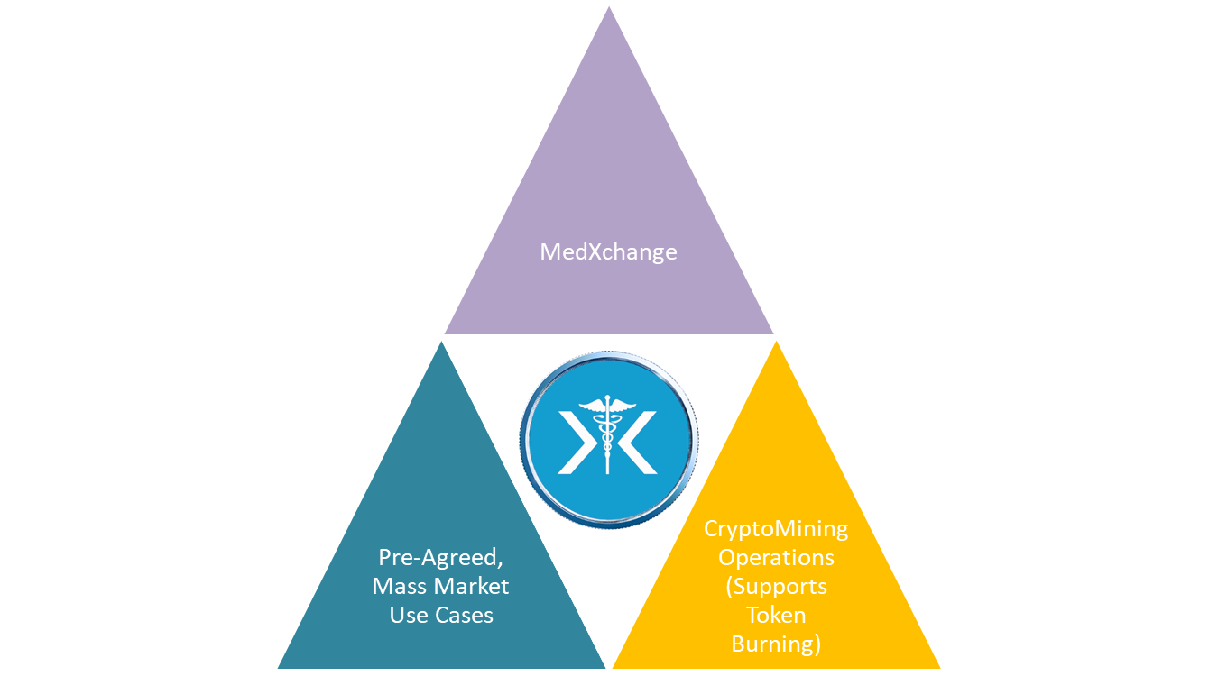

An optical view of the MedXchange / MedCash system in relation to the entire initial medical device ecosystem[19], designed for optimal success is as follows:

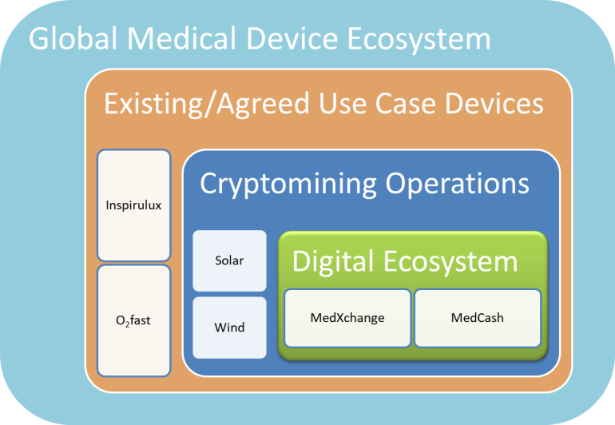

In evaluating the diagram we start with our proposed digital operations – the MedXchange platform facilitated by MedCash (the two together forming the digital ecosystem represented by the nucleus in green). Then, then moving outward, we observe how the digital system is supported by our own cryptomining operations. The cryptomining operations will comprise our own datacenters. The datacenters will be powered by a hybrid solar park solution comprising a solar farm combined with wind turbines to provide renewable, sustainable efficient and affordable energy, while reducing the impact to our environment.

Next, we have in orange the medical devices already committed to using the system. These devices are owned by MedXchange’s co-sponsor Kwivik Medical, Inc. (KMI). We believe that we will add other devices and Sell-side User companies very quickly, as we have, collectively in excess of 200 years of medical device experience and contacts in the medical device industry within our group. In the meanwhile, the already-committed devices, O2fast and Inspirulux represent significant “one-to-many” use cases for the MedXchange platform (discussed in more detail later). Further, we already have agreement with KMI that any and all additional medical technologies that they intend to acquire or develop in the future would be brought into the MedXchange system. KMI’s acquisition strategy involves purchasing similarly innovative medical device products, supplies and services companies, representing additional “one-to-many” and “many-to-many” use cases. As stated already, and perhaps should be re-emphasized, beyond the KMI-provided use cases, the global medical device industry is enormous ($340 Billion in 2016 growing to $435 Billion in 2020) and will provide immediate one-to-many and many-to-many use cases. Finally, once we have established a solid beachhead in the medical device industry we plan to bring other regulated healthcare industries such as pharmaceuticals, laboratory equipment, and services.

## Description of the Committed Use Cases – O2fast and Inspirulux

### Overview

KMI owns numerous issued patents and other patents pending on a proprietary process and methodology that is revolutionizing the emergency/short duration oxygen supply marketplace and which makes the delivery devices lighter, safer, more affordable and easier to use. This novel technology is unique: ***Medically pure oxygen is created instantly when needed from a catalytic reaction of two dry, proprietary powders*** inside a specially designed dispenser made of lightweight, usually thermoplastic, materials. The powders are dry and inert, until a button is pushed bringing them together, and the oxygen is generated instantly. KMI calls this technology, the “**oxygen from powder**” technology.

#### O2FastTM

**[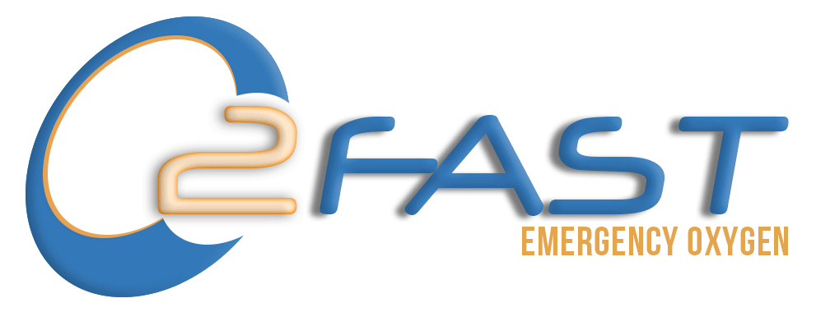](http://www.o2fast.com)**

O2Fast is a portable emergency oxygen device for lay person use, and the device uses the “oxygen from powder” technology. That means, there are no oxygen storage, no compressed tanks, no dials, no valves, and no shipping complications. Simple to use and requiring no training, O2Fast bridges the gap between the onset of a medical emergency and the time first responders arrive on the scene. It allows a *lay rescuer* – a bystander or loved one – to administer medical oxygen during those first, critical minutes after an emergency occurs, improving outcomes and saving lives in the process.

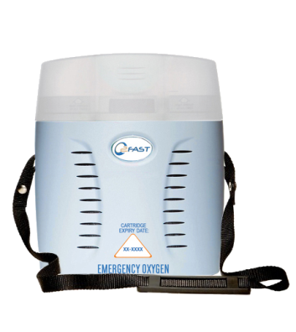In most medical emergencies involving cardiac or respiratory distress, or in the home and workplace of individuals with such risks, quick access to oxygen can be essential to survival and initial stabilization. O2Fast improves access to emergency oxygen that affects the survival, recovery and safety of individuals in several areas of need: (1) Public and private places and settings where medical emergencies can occur; (2) Individuals at risk for cardiac, respiratory or general medical distress needing immediate help prior to emergency medical care arrival; and (3) Those requiring immediate protection and escape from exposure situations or oxygen-deficient situations in industrial, mining, military, or other “Immediately Dangerous to Life or Health” (IDLH) environments. O2Fast is also an ideal companion product to an Automated External Defibrillator (AED).

O2Fast provides medical grade oxygen with the turn of a knob. Any lay person or bystander can use it in any medical emergency. The device comes with a reusable housing and a disposable, replaceable single-use cartridge. This cartridge has a shelf life of 2 years. The device produces a minimum of 6 liters per minute (LPM) for a minimum of 15 minutes (however it typically runs approx. 20-25 minutes). The idea is to run for enough time until a paramedic arrives or the patient reaches the hospital or clinic nearest to the emergency if applicable. Most customers however, keep extra cartridges on hand to extend time if needed or to have additional units available in case of multiple emergencies.

The immediate market for O2Fast is 3.5 million units (which is the size of the existing AED installed base) with a global potential of up to 500 million units. Why? First of all, O2Fast is a perfect companion product for AEDs. The reason is that if an AED is used in a cardiac arrest event, and the affected victim’s heart is resuscitated, then the most immediate need after that is oxygen. That is because the person’s heart would have stopped pumping oxygen to the brain and vital organs during the period that the heart was experiencing fibrillation. The oxygen requirement is critical, yet oxygen tanks are not available in public places and are not suitable for lay person use (oxygen tanks require careful use and extensive training to use). In other words, the oxygen piece has always been missing from the equation, until O2Fast came along, addressing this life-and-death gap in the global market. The criticality of oxygen in any heart emergency is underscored by the fact that, brain damage starts to kick in after approximately 3 minutes of oxygen deprivation. Further, the damage increases about 10% for every minute after that.

Beyond the “AED companion” market, O2Fast is applicable to any medical emergency worldwide, but it is *at least* applicable to: (i) any *person* who is at risk of a heart attack; and (ii) any *place* where a heart attack is likely to occur. There are in excess of 500 million people worldwide who are diagnosed with some form of heart disease, according to the World Health Organization.

KMI intends to commercialize O2Fast in many jurisdictions by using rental models. This will aid rapid adoption and make it affordable. That means, customers will be provided the units without the need to pay for the entire cost upfront. Instead, the customer will only make monthly rental payments to make it extremely affordable, helping to deploy the units with maximum speed. With O2Fast being deployed on the MedXchange system, these monthly payments will all be made with MedCash (MEDCASH). So for example, if KMI has 1 million units on deployed, there will be 1 million MedCash payments made on the MedXchange system every month (that is 12 million payments every year). It is easy to see how the number of users and the number of transactions on the MedXchange system can grow exponentially, driving the value of the currency. Additional information about O2fast can be found here: <https://kwivik.wixsite.com/o2fast> [20]

#### InspiruluxTM

Inspirulux is a kit comprising the O2Fast system combined with a nebulizer kit to administer aerolized albuterol (or similar bronchodilator) for use in asthma attacks or asthma exacerbations. During asthma attacks, victims initially require high flow supplemental oxygen (O2) above all (6LPM or higher), followed by nebulized or aerosolized albuterol.

According to a British Medical Journal article “Oxygen Treatment for Acute Severe Asthma” by Dr David Inwald, a UK paediatric intensivist:

“…*the use of oxygen before, during, and after nebulised B2 agonist therapy in primary care and in the community is rational and could save lives*.” [21]

Inspirulux answers this call. It is new, and just like O2Fast and there is nothing like it anywhere on the global market today. Why is this breakthrough significant? That is because all the major asthma exacerbation protocols such as for example the American Lung Association, Red Cross, etc require (high flow) emergency oxygen in tandem with albuterol or epinephren for asthma exacerbations. This creates a remarkable market need because a simple and safe combination kit (that does *not* involve a dangerous compressed tank) has not been available prior to Inspirulux.

Asthmatics are typically unable to negotiate an inhaler when used alone, or, when used with a spacer, they are unable to make a seal around the spacer’s mouthpiece. Either way, albuterol inhalation is much reduced. And, either way, if the oxygen mask is already on the victim’s face, it must be removed in order to (attempt to) provide the albuterol, depriving the victim of oxygen while trying. The Inspirulux kit combination assembly solves this problem, allowing lay responder administration of oxygen and albuterol (as taught individually to lay responders by the Red Cross et al) *simultaneously* without the need for any coordination or cooperation by the victim. This can make the difference while awaiting an EMS response.

Inspirulux addresses a remarkable gap in the worldwide asthma market. All asthma protocols (including, but not limited to the American Lung Association, Red Cross and many others) require the administration of both a bronchodilator and emergency oxygen in an asthma emergency. However, oxygen modalities and related issues have to date not allowed for mass lay person availability, and moreover a single solution that effectively combines both oxygen and a bronchodilator have never been available. Inspirulux closes this glaring gap, and focuses on patients with asthma, allergies and other similar respiratory conditions ***where oxygen is clinically indicated, at least partially for exacerbation management. The size of the asthma market in the U.S. is approximately 24 million patients, and worldwide it is in excess of 300 million patients. The worldwide asthma population is expected to grow to 400 million patients in 2025***.

Through the agreement with KMI, the Inspirulux product will be deployed on the MedXchange platform and over time we expect that hundreds of thousands, if not millions of Buy-side Users will be on the platform by virtue of these two products alone, conducting millions of transactions every year with the MedCash (MEDCASH) currency.

Finally, it should be noted that KMI acquired these products through an asset purchase in late 2016. KMI has temporarily taken them off the market while finalizing the “Generation II” version of O2Fast, outsourcing the manufacturing operations in order to add mass scalability, and tweaking certain business operations prior to relaunching. A copy of a slide presentation discussing the acquisition can be found here:

<https://docs.wixstatic.com/ugd/a6d7cc_943942bd78dd4c6191d6e21ea737c063.pdf>

## How will the Supply Chain be Disintermediated in General?

The following diagram illustrates, generally, how the medical device supply chain is set up:

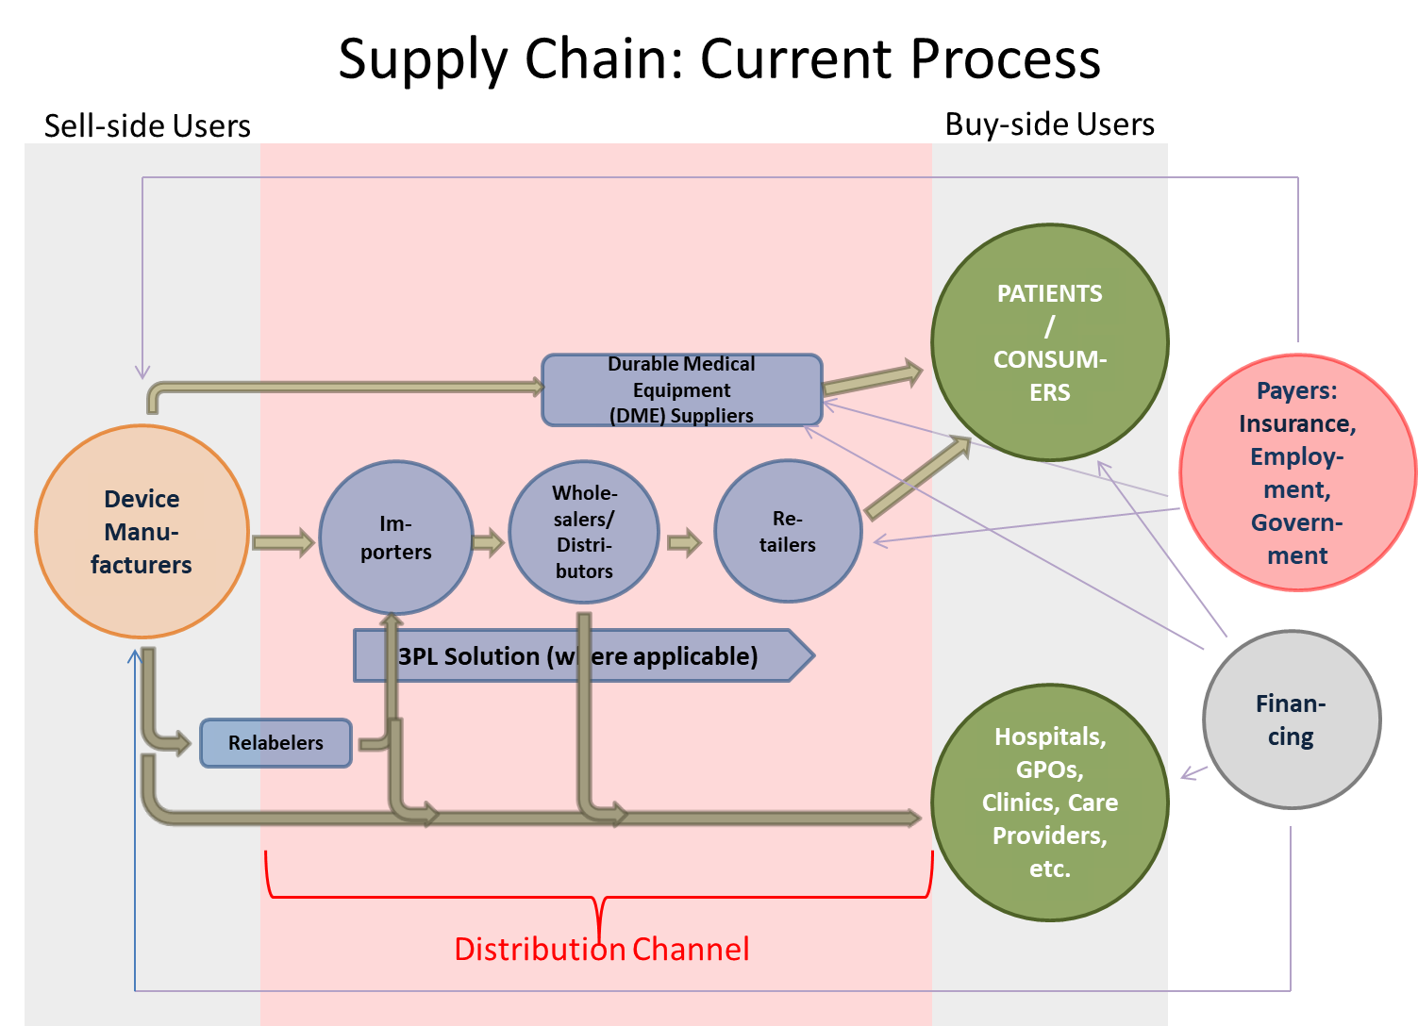

Legends: Medical device product flow (The view is a simplified view of a typical global medical device supply chain. Variations by product, country, regulations, and channel can occur)

Payments / cash flow (Also please note: Patients / consumers also make payments to Sell-side suppliers, either in whole or in part (such as for example in the form of a deductible or co-payment)).

While there are certainly variations on the theme, and differences in various countries and markets, the above illustration is generally appropriate. If a Sell-side manufacturer is smaller or regionally focused and only selling in their home market, some elements of the supply chain might not be relevant (such as for example, importer, 3PL provider, etc). So generally there are multiple layers in the middle – the distribution channel – creating many layers of cost associated with delivering a device to an end customer. Please note: an end customer (a Buy-side User in the MedXchange system) could be a patient / consumer directly; or could be a care provider, such as a hospital/hospital buying group, GPO or a clinic.

The following diagram illustrates, generally, *the most “optimal” situation* that the supply chain could migrate to:*

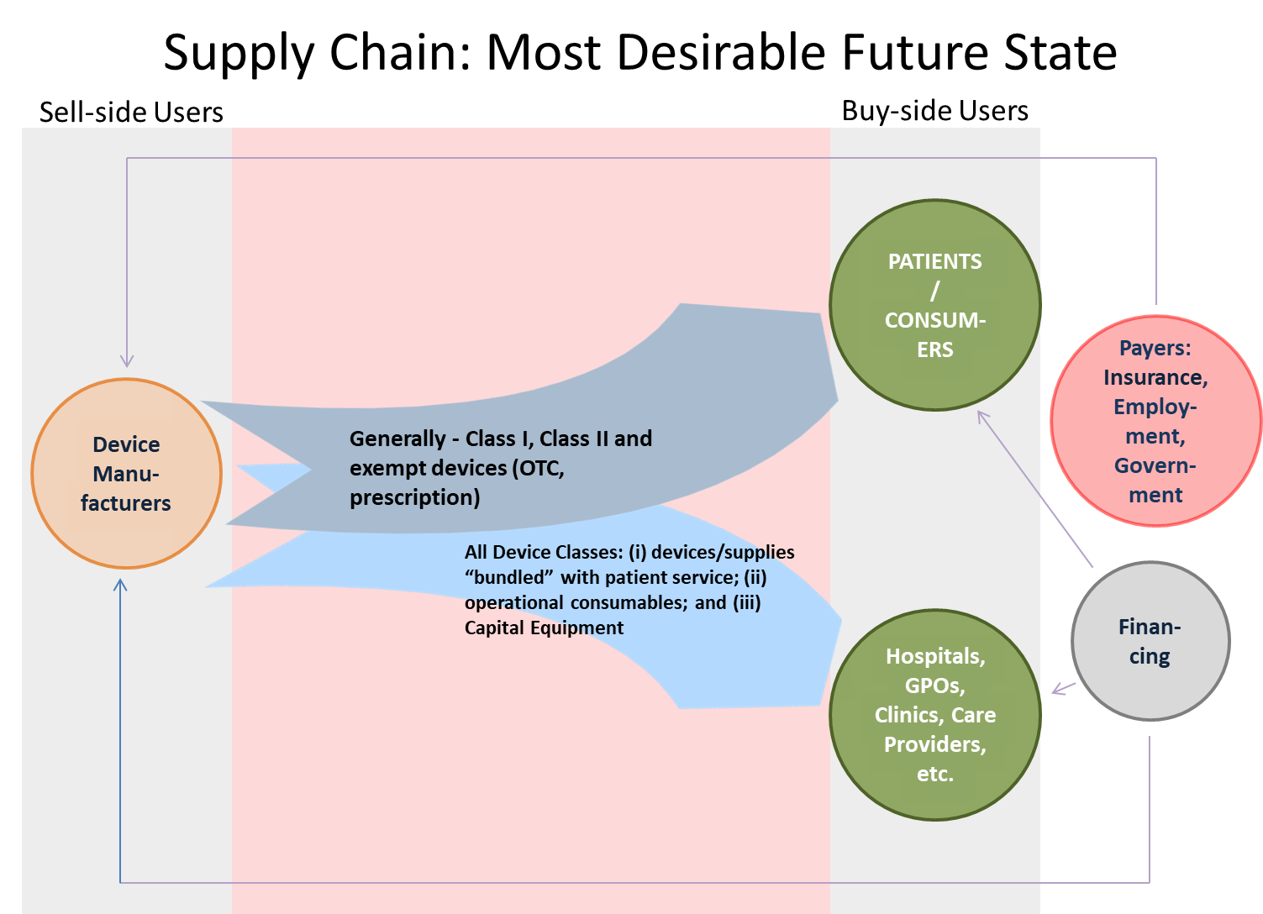

*Initially, some manufacturers will go direct (especially in their home markets) and some will go “***more direct***” (i.e. start with the elimination of one supply chain layer and then increase the disintermediation process from there.

## Attracting Users to MedXchange

We believe that MedXchange presents a remarkable value proposition and ***better aligns the interests of patients/consumers, care providers (hospitals, clinics, physicians etc) and insurance providers***. Cryptoeconomic business models offer financial utility and network value for all network participants and create strong incentives for early adopters to participate even before a critical mass of users is achieved. This is a new, promising path to overcoming the “chicken and egg” problem where, in the old model, networks tend to provide value to participants only upon reaching a critical mass of users. This is important in today’s landscape, where a few monopolistic industry players exercise powerful control that serve as a barrier to healthy competition.

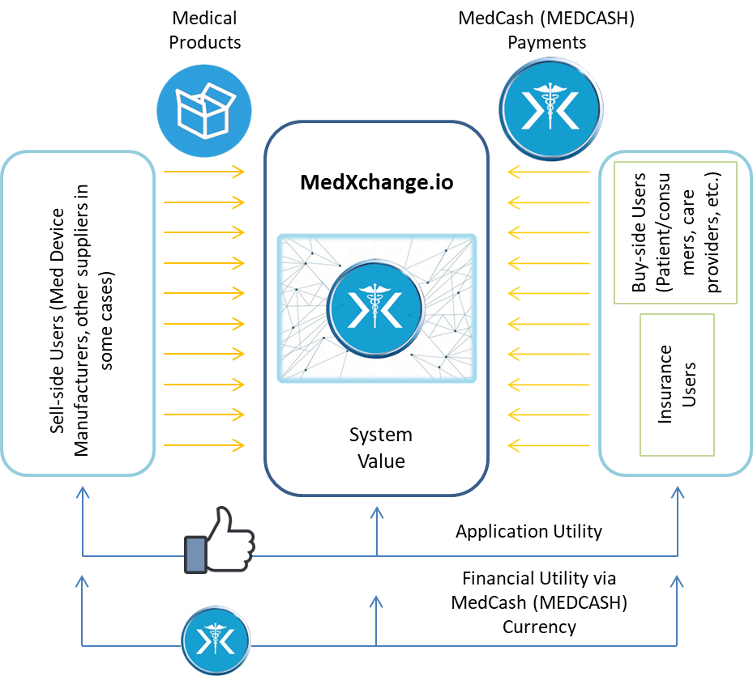

We believe we have a team that is uniquely positioned to tackle the opportunities for MedXchange, with decades of experience in medical devices combined with decades of experience in big data, blockchain, and engaging online content. We plan to deploy a Sell-side Customer Acquisition team to sign up Sell-side Users (manufacturers and sellers of equipment and suppliers generally) and whose focus will be lead generation, system onboarding, and implementation support. Initial Sell-side Users of MedXchange will be incentivized with MedCash (which they can use for various purposes such as rebates or discounts to customers, offset marketing expenses or defray shipping costs).

We will also have a team dedicated to Buy-side Community Development. Buy-side Users include millions of users of medical devices and supplies, worldwide. This will be done in multiple languages, but we will start with English. The buy-side team will provide education and support in using the system, including the use of MedCash, setting up and using the MedCash Wallet, and various other support activities.

We will utilize a pull strategy by rallying communities of Buy-side Users to petition device manufacturers to get on the platform through MedCash incentives that can be used as discounts or cost-offsets (think “Ask your doctor about…” type commercials, whereby a company petitions potential customers directly to drive action in the care provider community, i.e. a pull strategy).

We will also engage insurance players of all categories, including government, private and employer insurance categories. Insurance companies are uniquely incentivized by lower medical device costs. We may introduce MedCash incentives for insurance companies to board the system early, but we will evaluate this necessity as discussions progress.

### Advantages to Sell-Side Users of using MedXchange

The following represents a list that we believe, represents an initial set of advantages to Sell-side Users (manufacturers and suppliers) to boarding the system:

* No upfront cost to use – no financial barrier to entry
* Increases speed to market for sell-side manufacturers
* Increases margins by selling either ***directly or “more directly”*** to millions of patients and buyers globally (one-to-many); disintermediation can happen both in-country and overseas.
* Removes complexity in the supply chain
* Manage inventory better
* Allow regional and small medical device companies to go global faster and reach many more millions of customers in a cost effective manner
* Reduces the effects of product seasonality
* Manage obsolescence better
* Create demand visibility to the furthest downstream point; i.e. the end-customer
* Improve forecast accuracy
* Segment supply chains to better serve different (customer) demand profiles
* Accelerate product standardization
* Better control over customization / customer-driven solutions
* Growth of sales outside of the home market
* Maintenance of global branding consistency
* Reduction of supply chain expenditures (inventory, transportation, warehouse)
* Improved regulatory compliance, including improved ability to manage recalls
* Reduction of product spoilage and perishable loss (shelf life considerations)
* Improvement of asset utilization
* Improvement of working capital productivity
* Reduction of Total Length of supply chain
* Flexibility to offer multiple payment models (rental, lease, subscription, etc)
* Low transaction costs

### Advantages to Buy-Side Users of using MedXchange

* Lower prices
* More control and transparency
* More choices
* More payment options
* Allows individual patients and consumers to be more self-directed - Consumers will play a bigger role in healthcare decisions and choices, reflecting a switch in mindset from being “patients” to “consumers”
* No cost to onboard the system
* No transaction costs

## How will the Growth of MedCash as a CryptoCurrency be Supported?

Like with all currencies, value is a function of supply and demand. Therefore, ***the long term growth of MedCash (MEDCASH) is a function of the demand for the currency, which in turn is a function of the number, frequency and dollar volume of transactions***, and the value of the transactions. This, in turn will be driven by the number of users and the number of products on the system. In order to better illustrate the payment flows and the potential demand for MedCash we use a few examples.

Example 1 – For this example we will use an epinephrine autoinjector.[22] This is a prescription product, and the global market for this product was approximately 5.6 million units in 2016, representing USD 1.86 Billion in sales.[23] We need to make a few assumptions here: (a) We assume it is a new product launch (say, a new generic version) (b) We assume the manufacturer wants to do a launch in the USA, Europe and Canada (and has the appropriate regulatory approvals in place); (c) the average cost per unit is approx. $75 (selling / fulfilling prescriptions directly to patients using MedXchange); and (d) We assume an initial market capture of 250,000 units in year 1 (approx. 0.045% of the total market), followed by a growth rate of 12% per annum after that.

The following table shows the unit shipments and the USD equivalent demand for MedCash (MEDCASH) from this one product over 10 years:

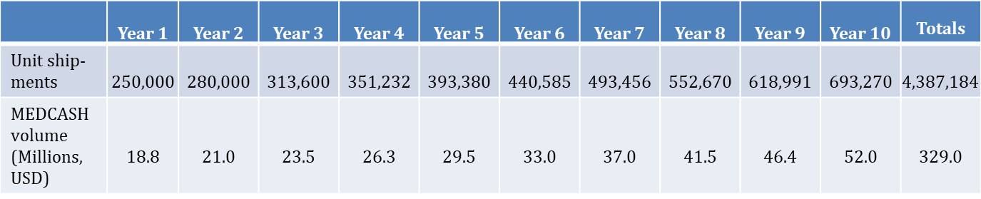

The table shows the total MEDCASH volume from this one product alone over 10 years accumulates to USD 329 Million.

Example 2 – For this example we will analyze a use case involving oxygen concentrators and one of the leading global manufacturers thereof (the numbers below are based on real/actual numbers from this company’s public disclosures). We assume: (a) 144,000 systems are sold globally by this company in year 1, growing at 20% per annum after that; (b) 31,000 units on rental at any one time (no growth); (c) 75% of the company’s business is in the USA and 25% comes from Europe; (d) In the USA the company sells directly to patients / consumers, but in Europe it sells through distributors; (e) rental revenues approximate 10% of sales revenues; (f) the average price per unit sold is USD 1,725; and (g) the company places only the European business[24] on the MedXchange platform, to increase margins and lower patient cost. In other words, it now wants to take its European business also direct, similar to its US model where it is already direct.

The following table shows the unit shipments and revenues and the USD equivalent demand for MedCash from this one product over 10 years:

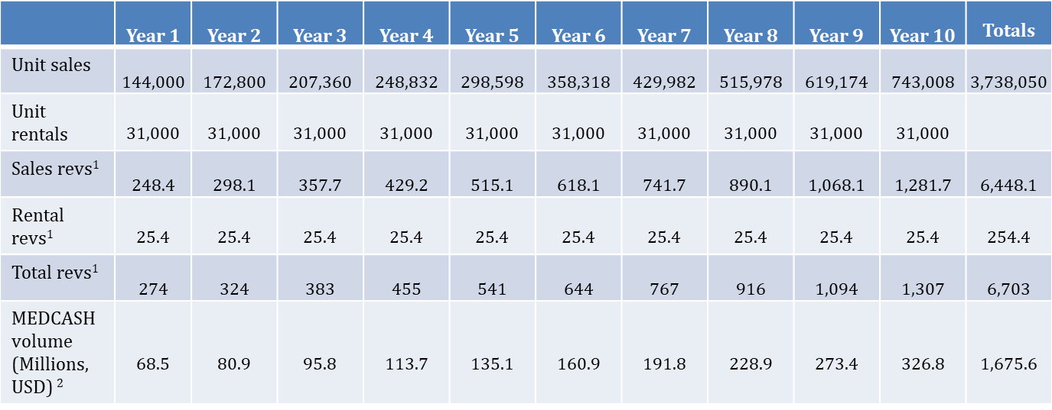

***Notes:*** (1) All revenue numbers are in millions USD. (2) Based on the European part of the business representing 25% of the total revenues.

The table shows the total MEDCASH volume from this one product alone over 10 years accumulates to USD 1.67 Billion. Further, it should be noted that the rental revenues represent at least approximately 3.7 Million *rental payments* over 10 years (31,000 rental payments per month, over 10 years). This is just an illustration to support our view that the medical device industry represents a remarkable opportunity for *consistency* of transactions over a long period of time. We believe that is good for the currency, MEDCASH.

Example 3 – We use a capital equipment example in this instance, whereby the Buy-side Users are generally institutional purchasers such as hospitals, GPOs, clinics and so forth. We choose hospital beds, which has some unique variability but are by and large commodity items subject to intense competition and pricing pressure. Some of the major players in the hospital beds market include Invacare Corporation, Joerns Healthcare, Arjo Huntleigh (Division of Gentige AB), LINET Group, Joh. Stiegelmeyer GmbH & Co. KG, Stryker Corporation, Hill Rom Inc., Paramount Bed Holdings Co., Ltd, Medline Industries, Gendron, Inc., Span-America Medical Systems, Inc., and Savion Industries Ltd, among others. The global hospital beds market is anticipated to grow at a CAGR of 4.7% from 2016 to 2021 to reach $2.36 Billion by 2021.

We assume: (a) A relatively basic electric bed with some bed controls and that is hydraulically operated (such as, for example, the Hill-Rom CareAssist); (b) the average purchase price per unit on the MedXchange platform is approx. USD 7,500 and does not increase; (c) The manufacturer provides financing at 5% interest rate for the beds over 24 months (and all these payments are made in MEDCASH); (d) first year sales comprise 1,000 beds globally growing at 4% per annum; (e) the average order size is 20 units per customer (i.e. 50 customers in Year 1); and (f) all the units are being financed and the number of payments calculation is treated as if all the beds are sold at the beginning of each period (for simplicity only).

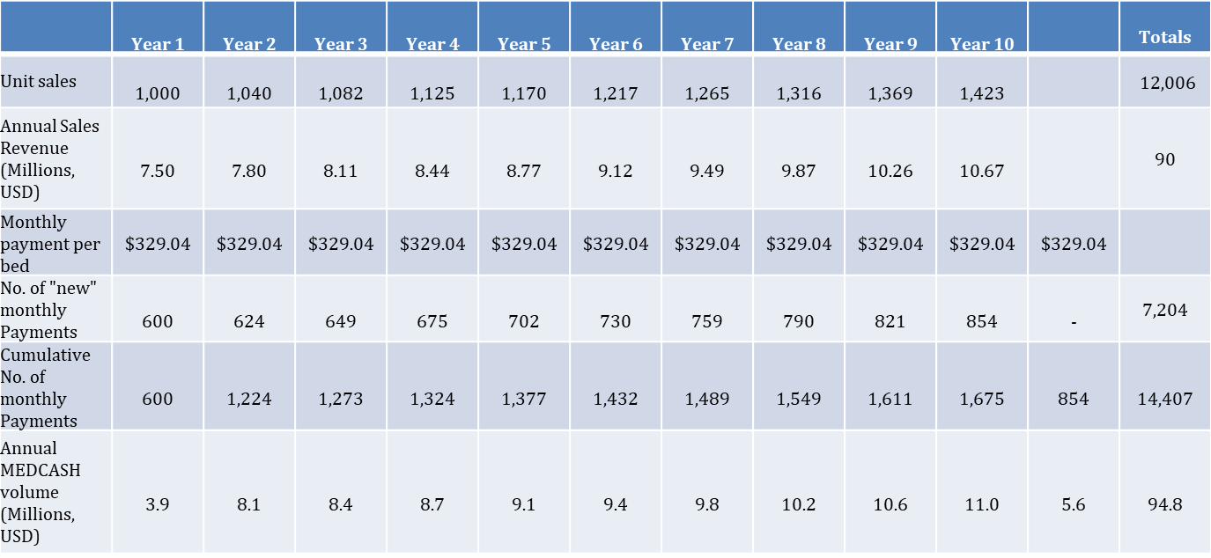

The table shows the total MEDCASH volume from this one product from this one manufacturer alone over 11 years accumulates to USD 94.8 million. What’s interesting about this use case is the sheer volume of monthly payments due to the financing. There are a total of 14,407 monthly payments, spread over 11 years. Similar to the rental payments in the concentrator example (Example 2) this repeatable consistency of transaction volume increasing over time is a significant contributing factor to MEDCASH’s consistency and growth over time.

Example 4 – Finally, we will analyze the use cases we already have agreements with, involving the O2Fast emergency oxygen product and the Inspirulux Asthma product. Please note, these products are vastly different from the oxygen concentrator product used in Example 2. Oxygen concentrators are used for COPD (emphysema, bronchitis, etc) and are generally, low flow (between 800 ml/minute and 3 liters per minute), low concentration devices prescribed by a physician, and sell at a cost of generally between USD 1,700 and USD 3,500. They are battery or electricity powered and the oxygen is breathed through a cannula through the nose.

In contrast O2Fast for example is a high flow device (a minimum of 6 liters per minute) and is for emergency use. It is sold over the counter (no prescription required) and each “use” costs approx. USD 249 (that is the cost of each of the “single use” replacement cartridges). The patient/customer purchases the whole system once for approx. $499 and after that only replaces the cartridges at USD 249 each (when purchasing the whole system it comes “rescue ready” – meaning, with a cartridge already pre-installed). The oxygen is breathed through a CPR mask. Inspirulux is a kit that basically combines the O2fast unit with a nebulizer kit, comprising a spacer chamber with a nebulizer port and an asthma mask. Inspirulux will sell at the USD 529 price point. Inspirulux is expected to be a prescription device. There is no such product available anywhere in the world today and Inspirulux is the first of its kind. A more comprehensive slide presentation discussing both O2Fast and Inspirulux and their respective markets can be found here:

<https://docs.wixstatic.com/ugd/a6d7cc_943942bd78dd4c6191d6e21ea737c063.pdf>

We assume: (a) All units are sold direct to retail patients / consumers; (b) O2Fast sales start at 2,500 units in Year 1 and grow at 40% per annum after that; (c) the “re-order rate” on the O2Fast replacement cartridges is approx. 50%; meaning, for each unit sold one replacement cartridge is sold within the following 12 months; (d) Inspirulux sales only start in Year 3 but at 5,000 units in Year 3 and grow at 50% per annum after that; (e) the “re-order rate” on the Inspirulux replacement cartridges is also approx. 50% also; and (f) all the units are deployed as rentals, and rental payments are made over 24 months (which is also the shelf life of each cartridge). The replacement cartridges for both O2Fast and Inspirulux are USD 249 each, and are paid over 12 months. Finally, and for the sake of simplicity we assume the units are sold at the beginning of each period.

The following table represents the projections for this use case, representing unit sales over 10 years, and the resulting monthly payments going through the MedXchange platform (showing both the volume of transactions and the MEDCASH volume). Please note that because the business model is based on a rental model - i.e. units are paid in monthly payments by the customer of 24 months (12 months in the case of replacement cartridges) – the cumulative transaction volume gets interesting very fast. The important issue is that *it creates a consistent stream of transactions through the system*, and these types of recurring revenue use cases are frequently found in the medical device industry. Further, we believe that these recurring revenue models (which include any devices that are financed by the manufacturers) will accelerate in prevalence in the future.

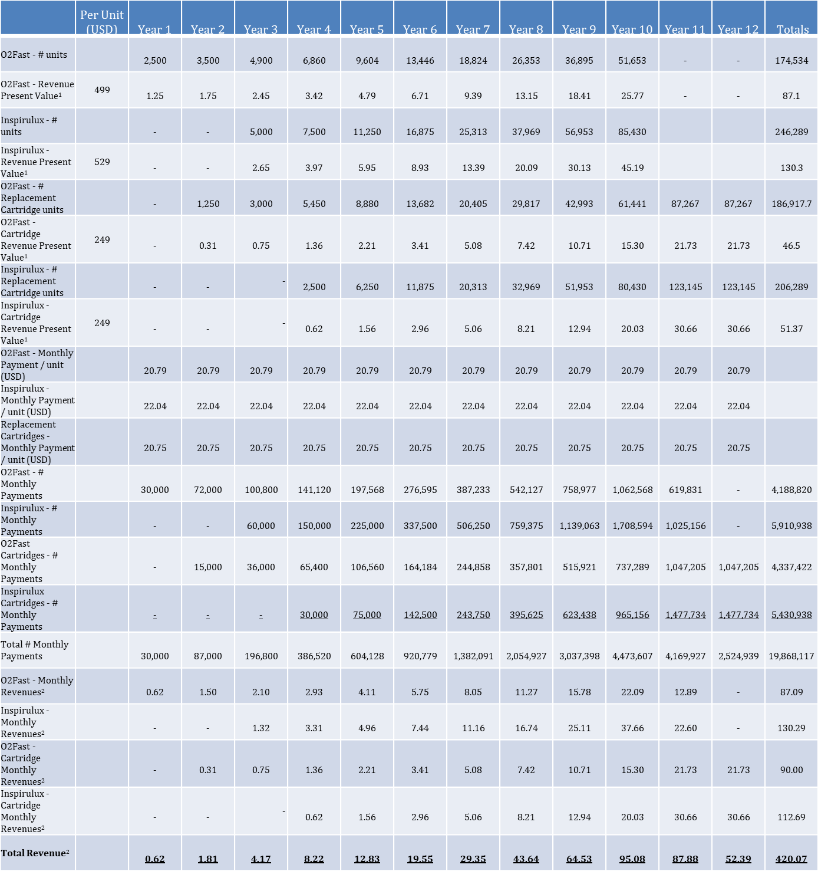

Notes: (1) All *annual* revenues and totals on these lines are in Millions USD. (2)Represent the MEDCASH equivalent in transaction volume on the MedXchange system.

The table shows the total MEDCASH volume from these two use cases from KMI alone over 12 years[25] accumulates to approx. **USD 420 million**. However, as a result of the rental model there is an astounding ***19.8 Million monthly payment transactions*** being processed through the system over 12 years.

We believe we can show thousands of examples of use cases involving products and businesses by country, industry vertical or region that can be brought onto MedXchange representing many billions of USD equivalent annual MEDCASH volume, and transaction volume involving many millions of transactions. We believe that adoption will be phased, but fast. Smaller / regional manufacturers and under-represented or under-funded manufacturers and suppliers will be incentivized to jump on board first and more quickly. Larger manufacturers will take “baby steps” and start with pilot projects first. From there, adoption will accelerate. ***In general, we believe it is quite realistic to assume more than $50 Billion in MEDCASH transaction value within the first 3 to 5 years subsequent to launch.***

We believe that for the next 20-30 years demand for MEDCASH *should* generally always exceed supply. Why?

1. ***Aging of the global population*** – as adoption grows, more and more Buy-side Users will come into the system needing ever-more MedCash currency to purchase their medical devices and supplies cost-effectively.
2. ***Adoption mathematics*** – at a simple level, if the number of new products / companies boarding the system each year exceeds the attrition rate, the demand should exceed supply. The MedXchange business development and customer service teams will be driven to bring users on board at a rate that far exceeds the attrition rate, if any, and pay performance metrics will reflect this goal. This could / should be tied to overall system goals for new users, transaction volume, dollar volume, and so forth (i.e. these performance goals are not mutually exclusive).

# CryptoMining Operations

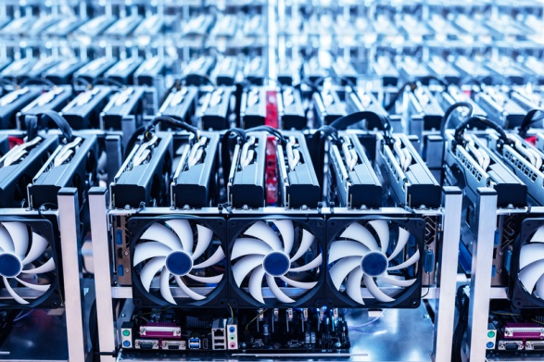We plan to dramatically expand our cryptomining operations to complement the digital MedXchange assets. We believe that this is a differentiator in how we bring together medical devices with the blockchain on both sides, not just the digital side but also the mining side. We believe that having our own cryptomining operations presents multiple strategic and tactical benefits. One of which is that the revenues from the cryptomining operations will support the token burning process during the first 3 years.

Cryptomining is rapidly evolving and growing, causing a global shortage in supply of chips and graphics processing units (GPUs). As regards the mining rigs used, processing power, speed, heat and efficiency are critical issues to watch when investing in the processors to ensure continued profitability. While 16nm ASIC chips are considered the current required standard for a serious cryptomining operation (as at the time of this draft), companies such as GMO and Samsung have already announced plans to produce the next generation of chips such as 7nm, 5nm and 3.5nm.

Long term, continued profitability for our cryptomining operations is a function of various factors, including, but not limited to:

* + Most importantly, *the cost of electricity*
  + The level of investment we make in current technologies
  + The amount of hedging against technology upgrades
  + The price of Bitcoin, Etherium and other cryptocurrencies that we mine (including our own currency, MedCash)

## Electricity Supply

### Solar and Wind Power

Our cryptomining operation will be powered by affordable, renewable and sustainable energy from a hybrid solar park which combines a solar farm that is co-located with a wind farm. This solar park will likely be based in Texas, USA but will be evaluate other sites in the USA and outside the USA based on location (the solar farm and the cryptomining datacenter will be collocated) and security, as well as other factors such as average sunshine, temperature, wind, tax incentives, grid parity, feed-in tariffs, and other economic and financial incentives provided by the applicable state, city, county and/or municipality.

### Capacity and Site Size

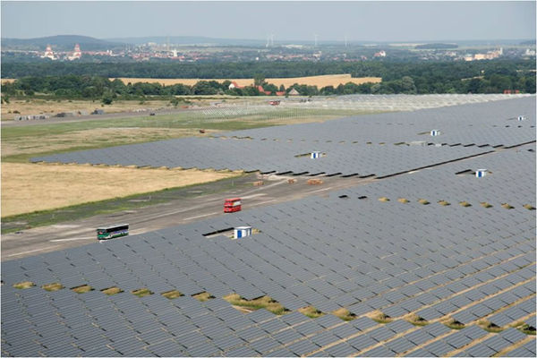We anticipate our solar park to have a capacity of at least 4 MWAC. To accommodate this capacity estimates and calculations of solar energy's land-use requirements are to be taken into account. Not surprisingly, there is a wide range of total land-use requirements depending on the type of solar technology and systems deployed at a site. Overall, generation-weighted solar power plants require on average a total of approximately 3.5 acres/GWh/year, ranging from 3 acres/GWh/year (CSP towers) to 5.5 acres/GWh/year (small 2-axis flat-panel PV). Direct land impacts on a generation-weighted basis 2.9 acres/GWh/year. On a capacity-weighted basis, total land requirements average out to 8.9 acres/MWac, and 7.3 acres/MWac for direct land use. According to United States National Renewable Energy Laboratory (NREL) a large fixed-tilt solar PV plant requires 2.8 acres per GWh/year of generation.

The following table represents a summary of land-use requirements for PV and CSP projects in the U.S.:

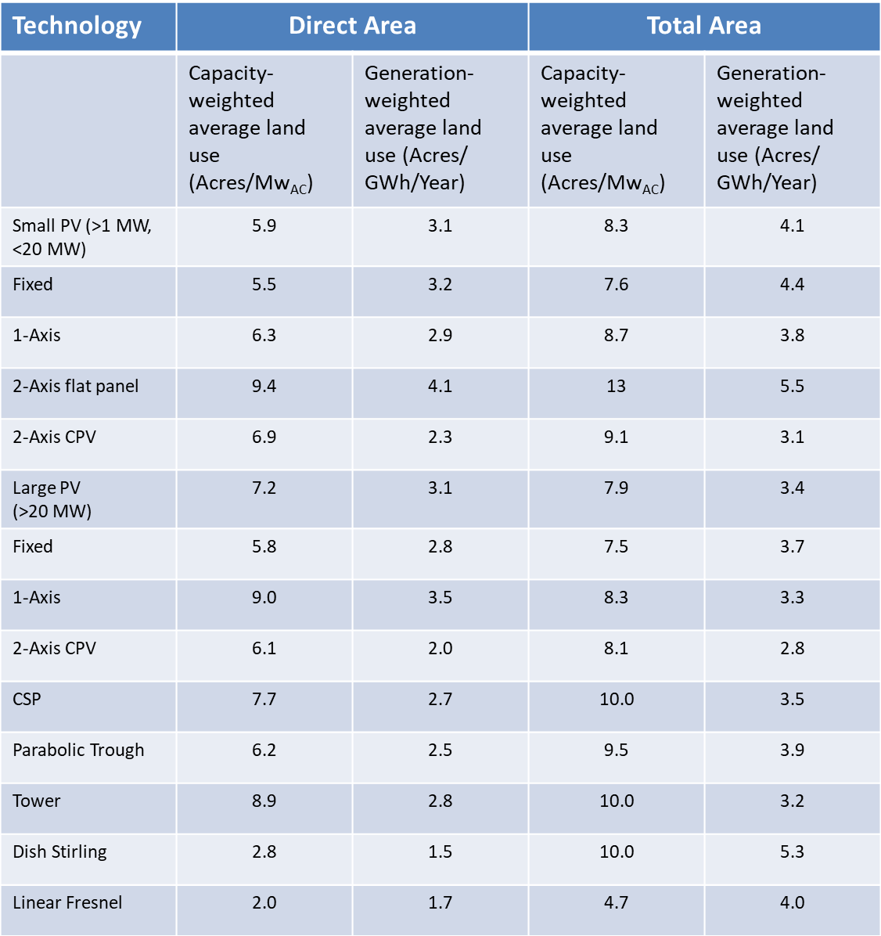

*Credit: NREL*

We anticipate that we will secure a site of no less than **40 acres** but probably larger to accommodate future growth and other additional requirements. In addition, we intend to evaluate the most efficient methods available to generate wind energy in order to supplement our solar yield, which in turn may necessitate additional land requirements. For example, the use of wind turbines may require additional acreage. Yale University in the USA calculated wind energy usage down to the turbine level, calculating 1-3 acres per turbine required.

# Our Initial Coin Offering (ICO)

There will be 200,000,000 million Tokens generated in order to provide the Crowdfunding. The Company plans to burn 50% of the MedCash (MEDCASH) tokens over the next 3 years.

## Coin Allocation

The total amount of Tokens realized at the end of the Crowdfunding is divided as follows:

* 55% is provided to Participants as a confirmation of funds transfer which includes a bonus in accordance with the distribution scheme, if applicable, described below;
* 15% is provided to founders and team members generally on vesting schedules
* 10% is provided to our Co-Sponsor and committed use case provider, Kwivik Medical, Inc.
* 1% is provided to pre-White Paper supporters
* 4% is provided to Consultants generally on vesting schedules
* 5% is provided as technical tokens for stabilization and partnerships
* 5% is provided as bounties to supporters of Medxchange for actions other than funds transfer in accordance with the distribution scheme;
* 5% is held for further development or as a liquidity reserve.

In addition, the percentage of tokens the team has will remain at 15% regardless of how many tokens are burned.

## ETH / MEDCASH Exchange; Bonus Tokens

**1.00 MEDCASH** will be provided for the equivalent of every **$.50 USD** which is transferred.

The following bonuses will be available during the two weeks prior to the ICO and the eight weeks of the ICO:

1. During the first 2 weeks prior to the ICO (the so-called “Pre-ICO Period”):

(i) During the first week of the Pre-ICO Period, **1.25 Tokens** will be provided for the equivalent of every **$.50 USD** which is transferred;

(ii) During the second week of the Pre-ICO Period (i.e. the week just prior to the Commencement Time), **1.20** Tokens will be provided for the equivalent of every **$.50 USD** which are transferred;

(b) During the first week of the ICO - **1.15** Tokens will be provided for the equivalent of every **$.50 USD** which is transferred;

(c) During the second week of the ICO - **1.10** Tokens will be provided;

(d) During the third week of the ICO - **1.05** Tokens will be provided; and

(e) During the remainder of the ICO – **1.00** Token will be provided.

Payment Accepted: Fiat/Credit Card; BTC, BCH, ETH, LTC, DASH, EOS, and

MONERO

Where: “Closing Time” means the *earlier* to occur of:

1. Upon reaching hard cap; or
2. **12:00 PM GMT on May 31st, 2018.**

“Commencement Time” means 12:00 PM GMT on **April 1st, 2018**.

A full disclosure of the ICO can be found at our website located at medxchange.io under “Terms and Conditions.”

# Our Teams and Partnerships

|  |  |
| --- | --- |
|  |  |
| Julian Ross, Founder/CEO (USA)  Over 30 years experience in technology, medical devices, and finance. Holds numerous issued patents. MBA (Finance) | Edward Huntsberry, VP of Customer Acquisition (USA)  Over 35 years experience in medical devices, sales, business development, real estate and retail |
|  |  |
| Alyssa Laurea, Creative Director (USA)  Over 8 years experience in web design, technology, and medical devices. B.S. (Business) | Sheryl Shea, Patient Relations (USA)  Over 7 years experience in Patient Advocacy, Patient Relations, and medical devices. B.S. (Pol. Sci./Gov) |
|  |  |
| Giorgia Pellizzari, Business Development, Marketing, Project Management  (Hong Kong)  Over 12 years experience in programming, business development and technology, including Siemens and Ikea | Vadim Zolotokrylin, Programming, Business Development, Contributor (Hong Kong)  Over 12 years experience in technology and crypto-ventures. Double Masters degree – Telecoms/Computer Technology and Innovations |
|  |  |
| Chase Freeman, Programming, Smart Contracts, Advisor (USA)  Over 5 years experience as systems analyst & web developer, blockchain evangelist, and technology solutions expert with projects all over the world | Jonathan Martin, Advisor (UK)  Over 30 years experience as an attorney and entrepreneur, with interests in technology, web development and professional services |

|  |  |
| --- | --- |
|  |  |
| Chris Kaplan, Advisor (USA)  Over 30 years experience in medical devices and “big pharma,” including Sanofi, Boeringer-Ingelheim, Novartis and Bristol-Myers Squib. | Albert Deweese, Advisor (USA)  Over 15 years experience in medical devices, software and SaaS, and business development. |

|  |  |
| --- | --- |
|  |  |
| Robert Sanderson, Investor, Advisor (Canada)  Over 40 years experience as a prolific investor and businessman, with interests in agriculture, real estate, and numerous small and mid-cap publicly traded companies. | Andrea (Zanini) Almeida, Legal Advisor (Brazil, USA) Over 20 years experience in international law, technology, data centers, and startups |

## Programming Partnerships



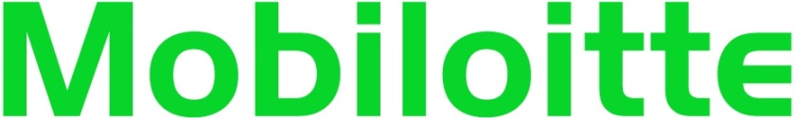

|  |  |
| --- | --- |
|  |  |

# Roadmap



1. In this situation, most medical devices serve as inputs in the delivery of health care services and are usually not considered services by themselves. The major exceptions are medical devices that are used as durable medical equipment, prosthetics, or orthotics.
2. 45 percent of the global market according to the U.S. Government Accountability Office's (GAO) 2014 statistics.
3. Source: Medical Product Outsourcing 2015.
4. BMI Research 2015, Donahue and King 2015, Gravelle and Lowry 2015.
5. BMI Research 2015, International Trade Administration 2010.
6. Per the Global Harmonization Task Force (GHTF), <https://www.gs1.org/docs/healthcare/ghtf-sg1-n071-2012-definition-of-terms-120516.pdf> , page 5
7. *Id.*
8. <https://www.fda.gov/MedicalDevices/ResourcesforYou/Consumers/ucm142523.htm>
9. *Id.*
10. *Id.*
11. Vitalik Buterin. Slasher: A punitive proof-of-stake algorithm (2014). https://blog.ethereum.org/2014/01/15/ slasher-a-punitive-proof-of-stake-algorithm/
12. Due to ongoing research by others including MedRec (Electronic Medical Records on the Blockchain), which goes in depth to this key system, we have strong reason to believe that this approach will aid compliance with HIPAA regulation and be able to be quickly adopted by the medical device industry.
13. It is important to note that this will be a large fork of the existing Ethereum project. Tendermint or Parity could be a stepping stone, so we are investigating these as possibilities.
14. Quality Assessment of System ARchitectures) method for assessing the quality of the architecture of a software-intensive system.
15. A Bloom filter is a space-efficient probabilistic data structure, conceived by Burton Howard Bloom in 1970, that is used to test whether an element is a member of a set.
16. See “[A Tutorial on Reed-Solomon Coding for Fault-Tolerance in RAID-like Systems](http://web.eecs.utk.edu/~plank/plank/papers/CS-96-332.pdf)” by Dr. J. S. Plank
17. See “[Tezos — a self-amending crypto-ledger](https://www.tezos.com/static/papers/white_paper.pdf)” by L.M Goodman.
18. *Id.*
19. As stated earlier in this white paper, we plan to attack the global medical device industry initially, but the MedXchange platform will be flexible and scalable to allow us to go other categories of regulated health care ecosystems, such as pharmaceuticals, laboratory equipment, and services.
20. Please note: KMI is currently making changes to the product to launch a “Generation II” version in the forseeable future. Prior to that, the O2Fast website is not public and can only be accessed through this link, for regulatory reasons.
21. <http://www.bmj.com/content/323/7304/98>
22. Epinephrine autoinjectors are hand-held devices carried by those who have severe allergies; the epinephrine delivered by the device is an emergency treatment for anaphylactic reactions. The most well-known of these is the so-called “Epipen.”
23. According to ReportsnReports, the global consumption of epinephrine products increased up from 3.38 Million Units in 2012 to 5.57 Million Units in 2016, with CAGR of 13.25%. At the same time, the revenue of world epinephrine sales market grew from 445.47 M USD to 1.86 Billion USD (which implies the cost per unit in the aggregate was approx. USD 337). <https://www.prnewswire.com/news-releases/epinephrine-market-2017-2022-auto-injector-prefilled-syringe-forecasts-research-report-available-at-reportsnreports-618525973.html>
24. The company has a European subsidiary already and has a small office and support infrastructure that it can easily “beef up” to accommodate the plan.
25. All uses cases are over 10 years, but in this instance residual revenues extend for 2 additional years due to the installment payments over 24 months and due to the residual revenues from replacement cartridge sales.